**Lab19**

**Cloud Formation – Microsoft AD**

Click “Cloud Formation”service.

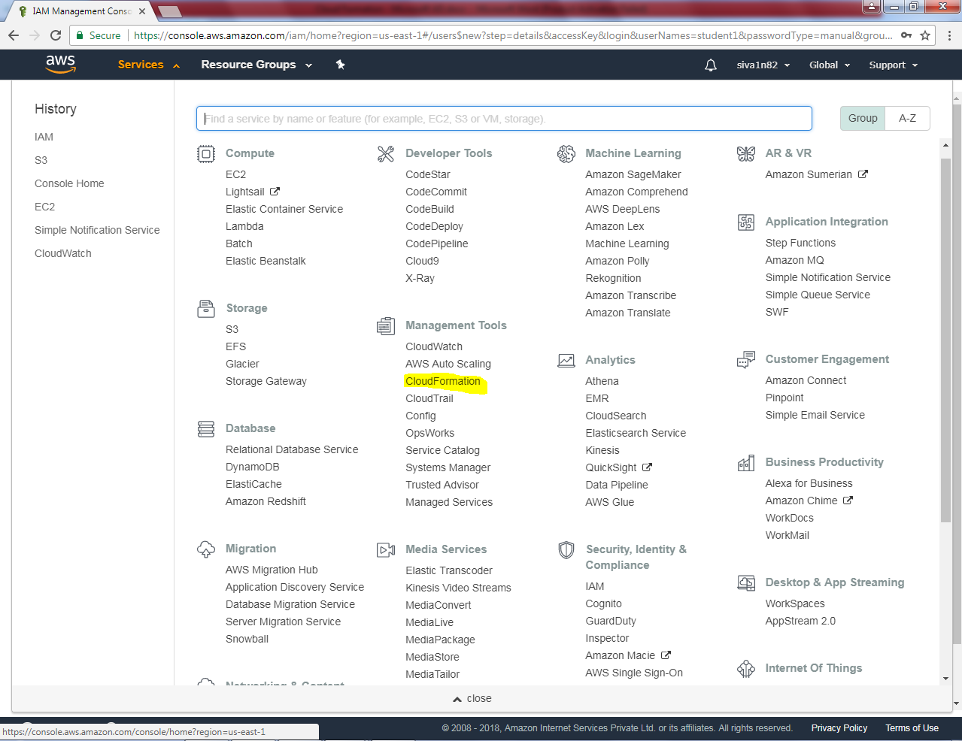

Click “Create new stack”.

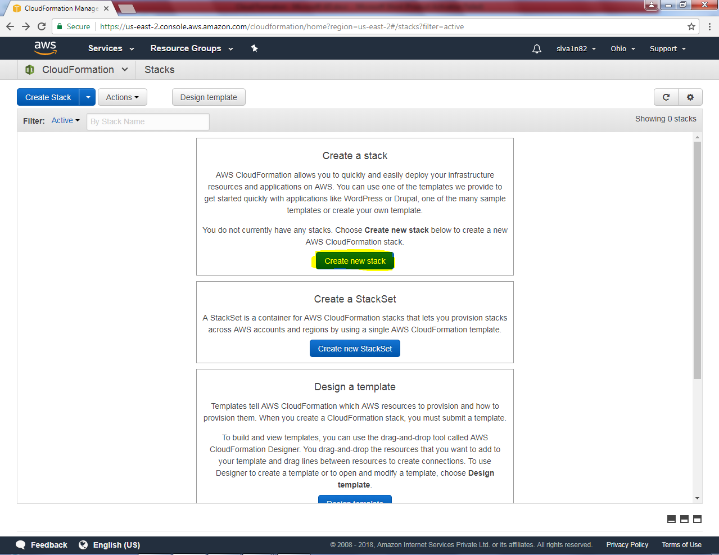

In Select a sample template, select “Windows Active directory”.

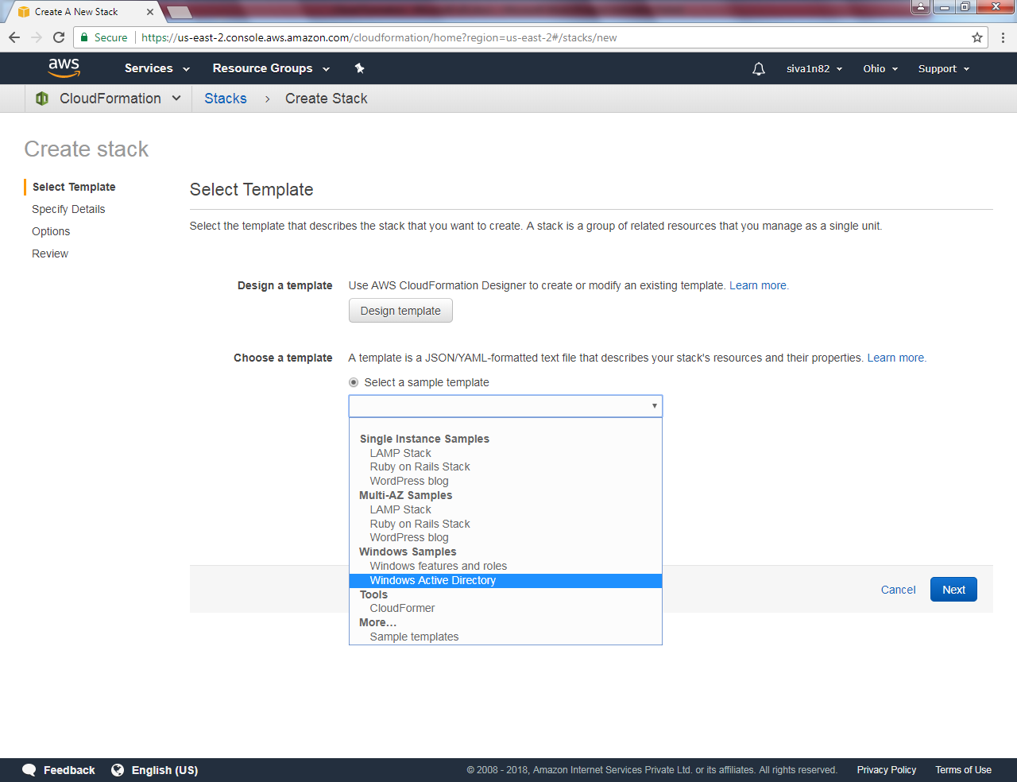

Click “Next”.

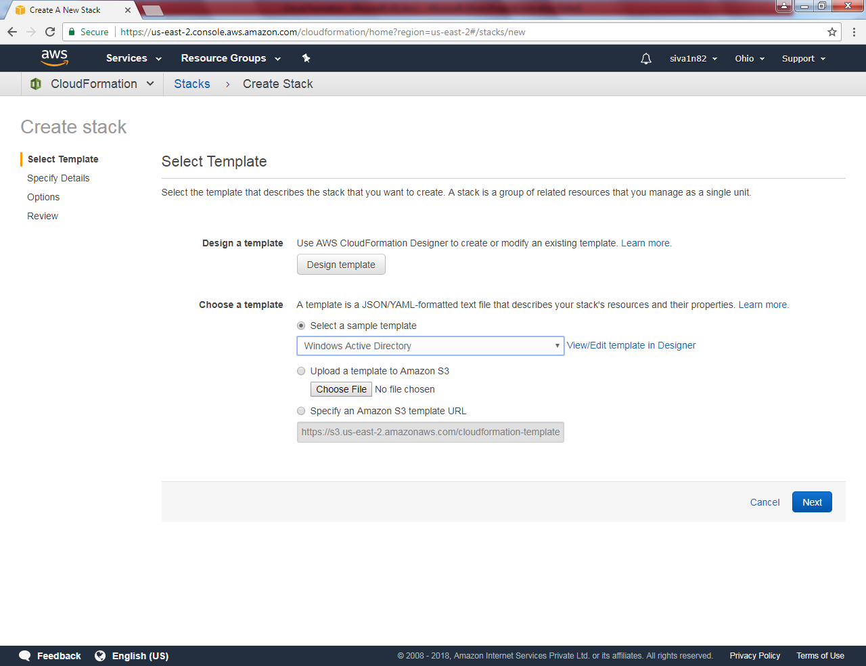

Type Stack name as “WindowsAD”, DomainDNSName as “Sansbound.pvt”, DomainNetBIOSName as “Sans”, Instance type “t2.micro”, keyname = (Select the keyname), Restoremode password as “12345678”, Source CIDR For RDP = 0.0.0.0/0

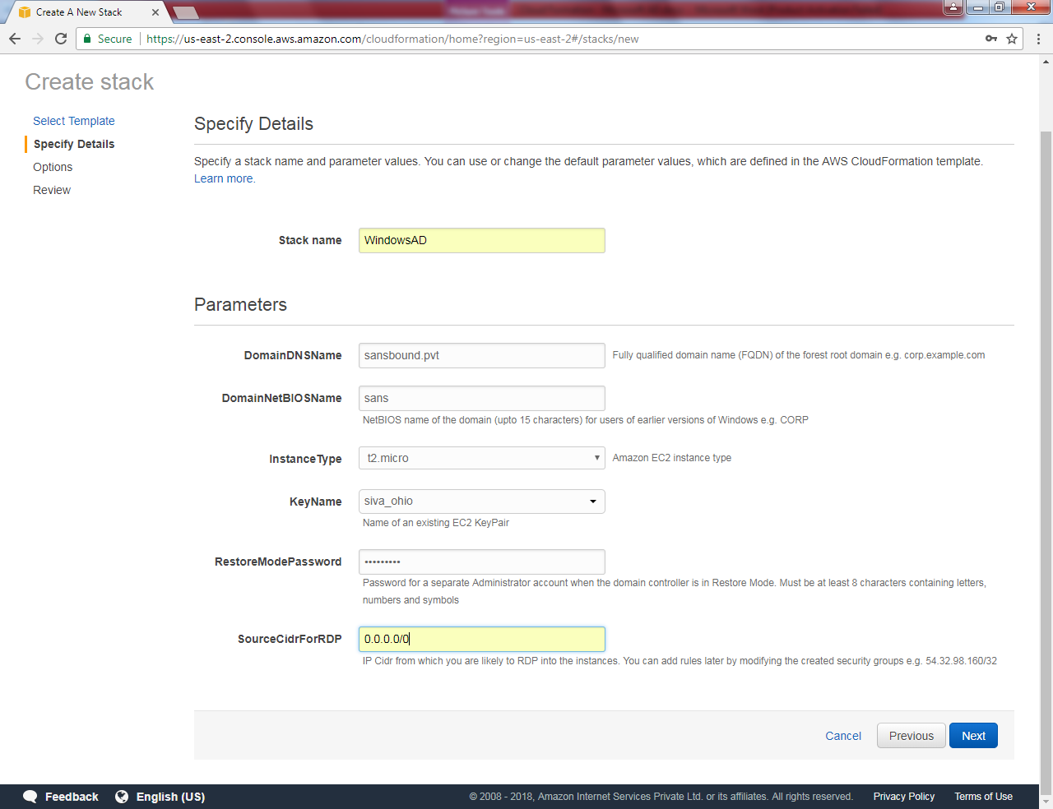

Click “Next”.

Leave default and click “Next”.

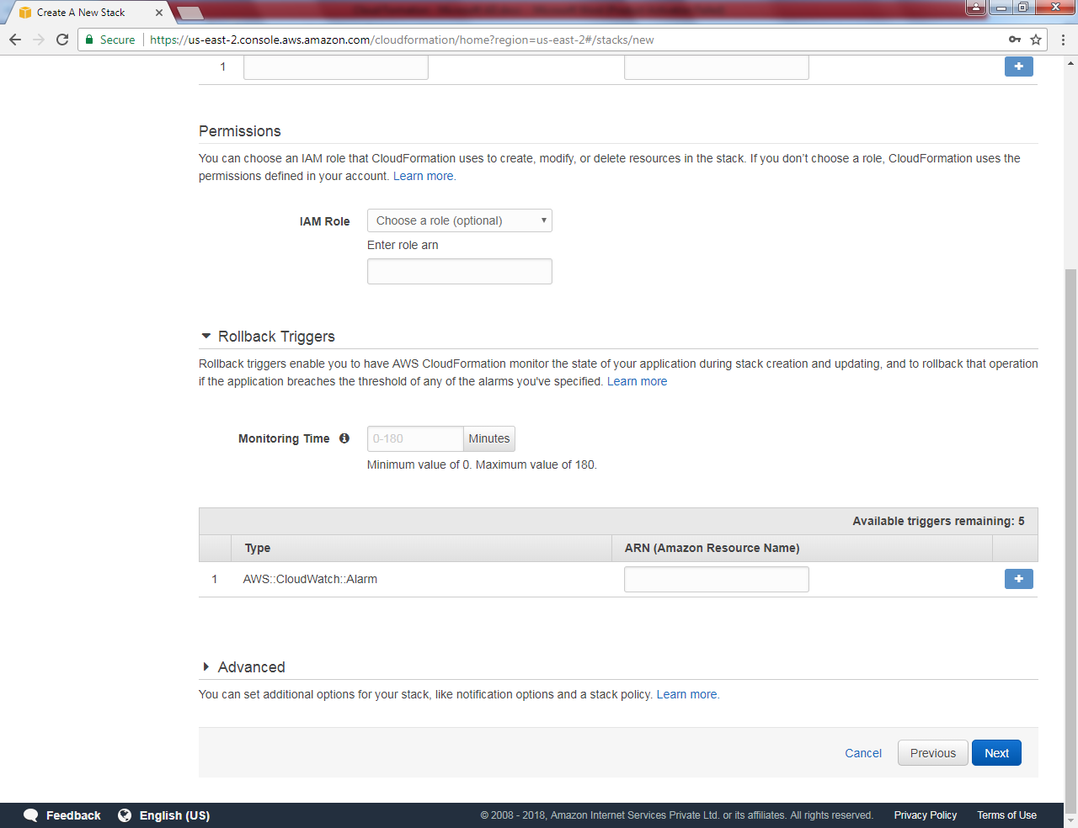

Click “Create”.

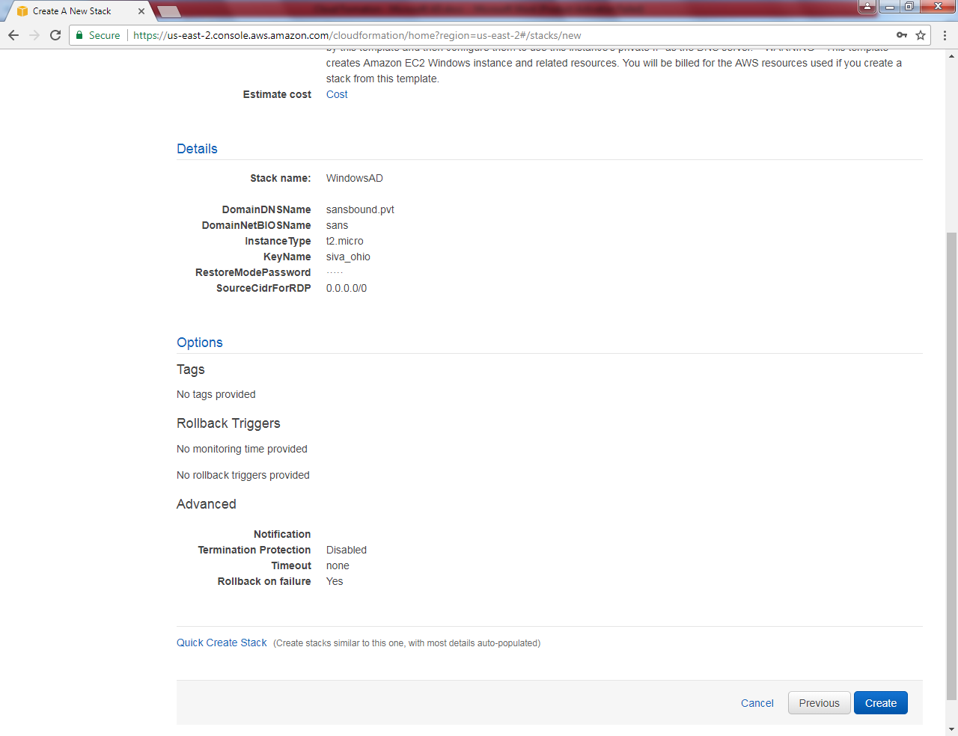

Wait for 15-20 minutes to create a server with DC.

DC created succecssfully.

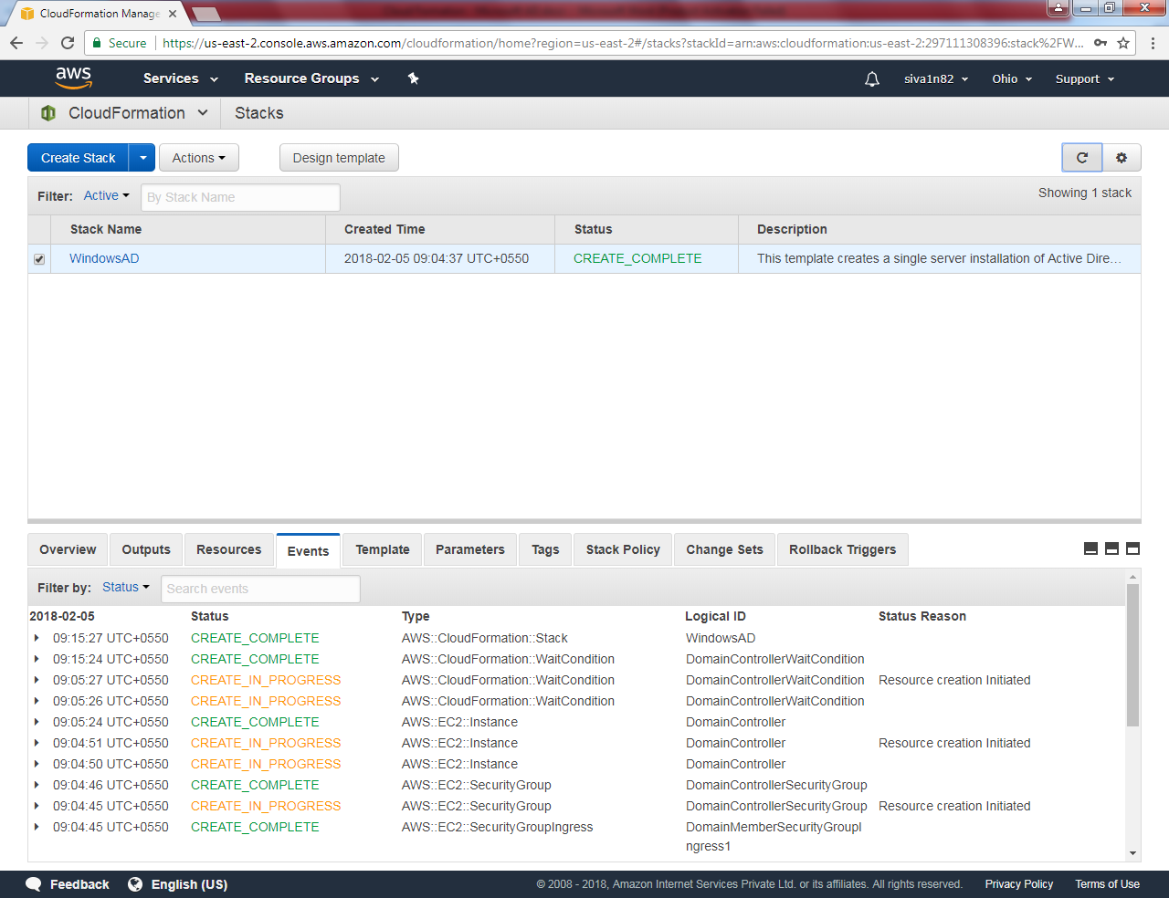

We need to launch instance in ohio for member server.

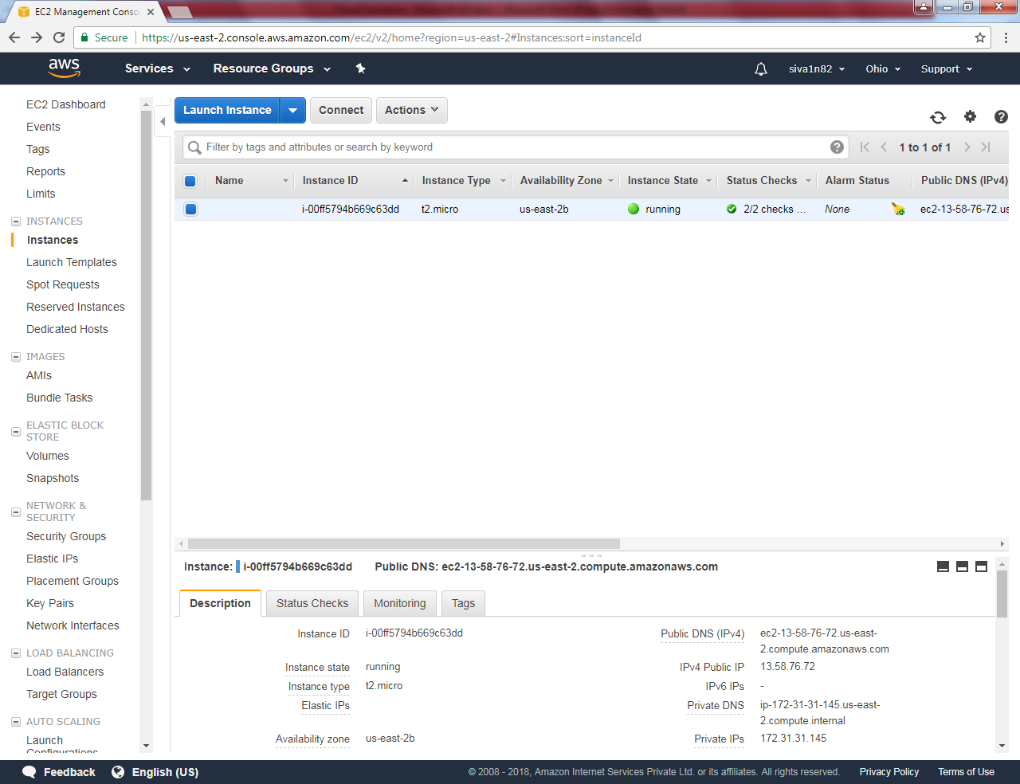

Select “Microsoft Windows Server 2016 Base”.

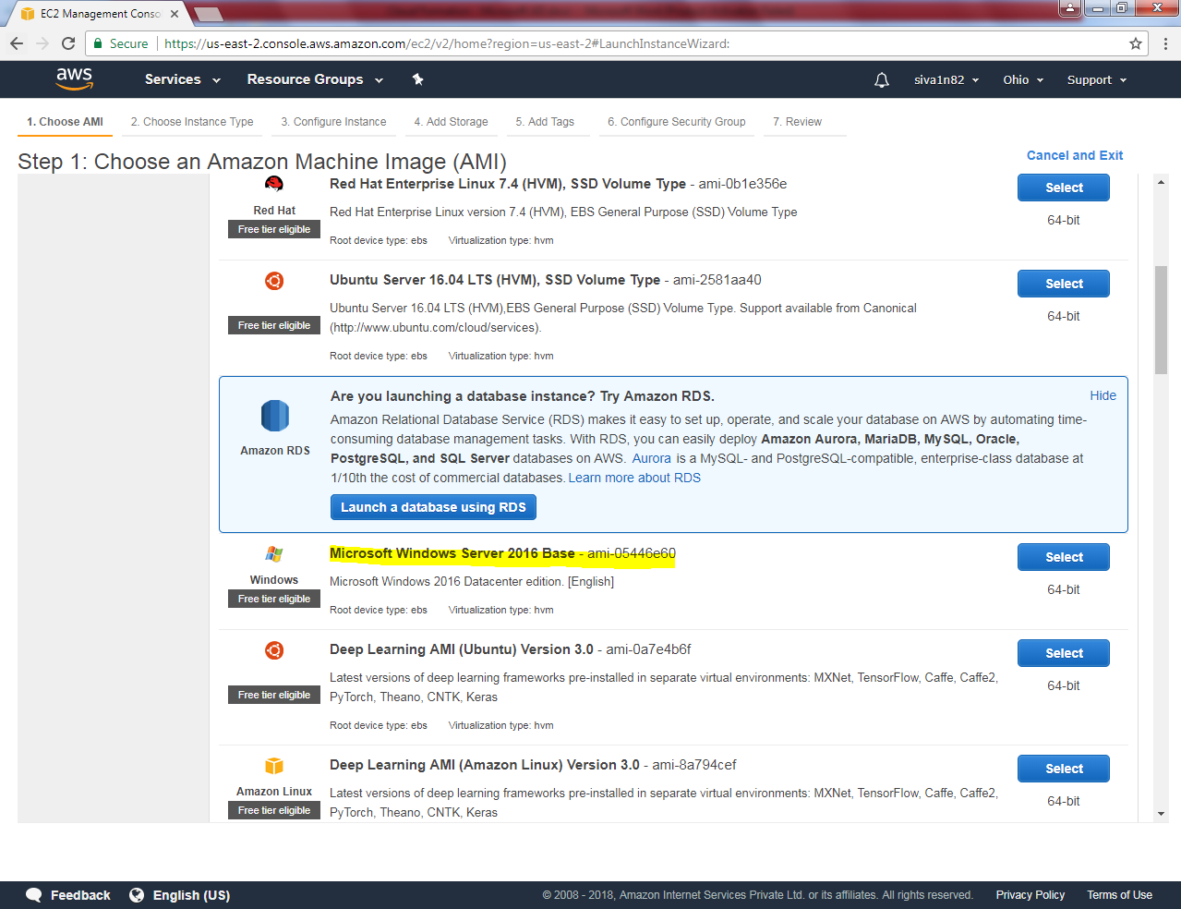

Select “t2.micro”.

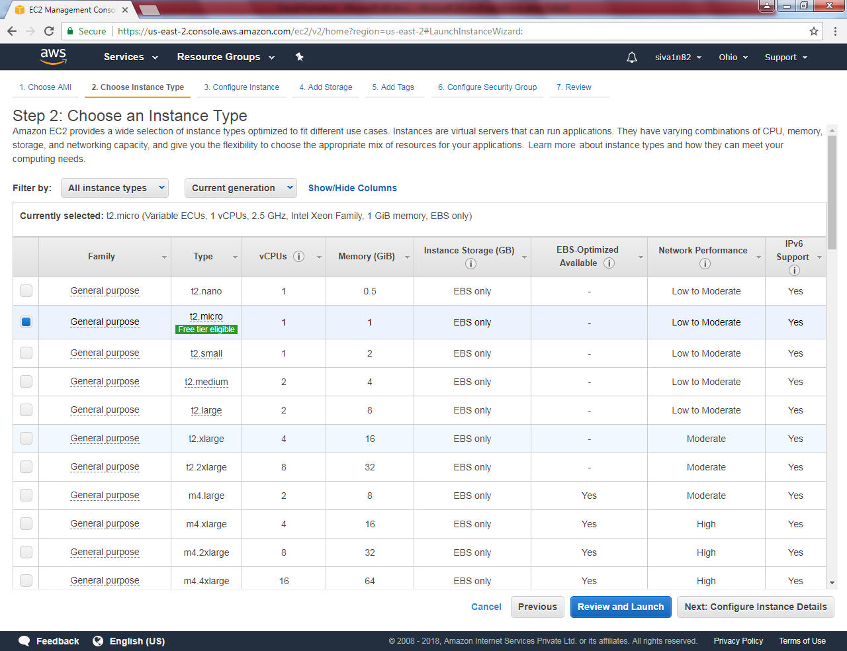

Click “Next”.

Leave default settings and click “Next”.

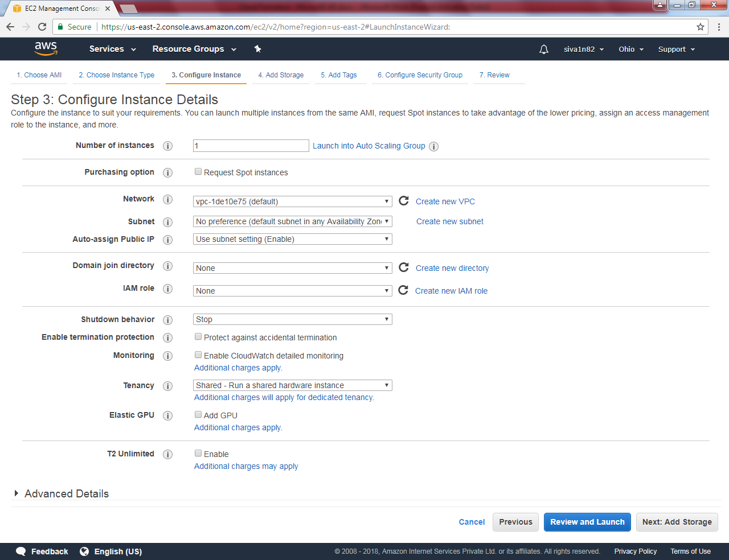

Click “Next”.

Leave default settings and click “Next”. 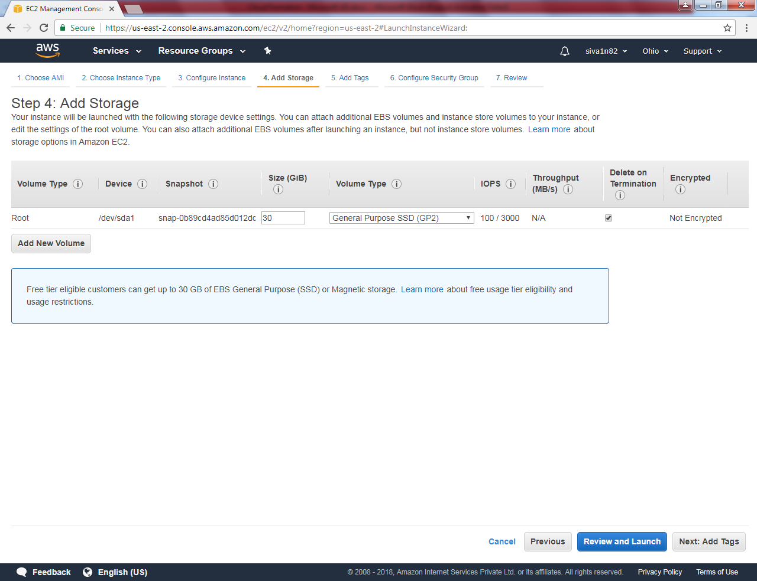

Key – Name

Value – Windows 2016server

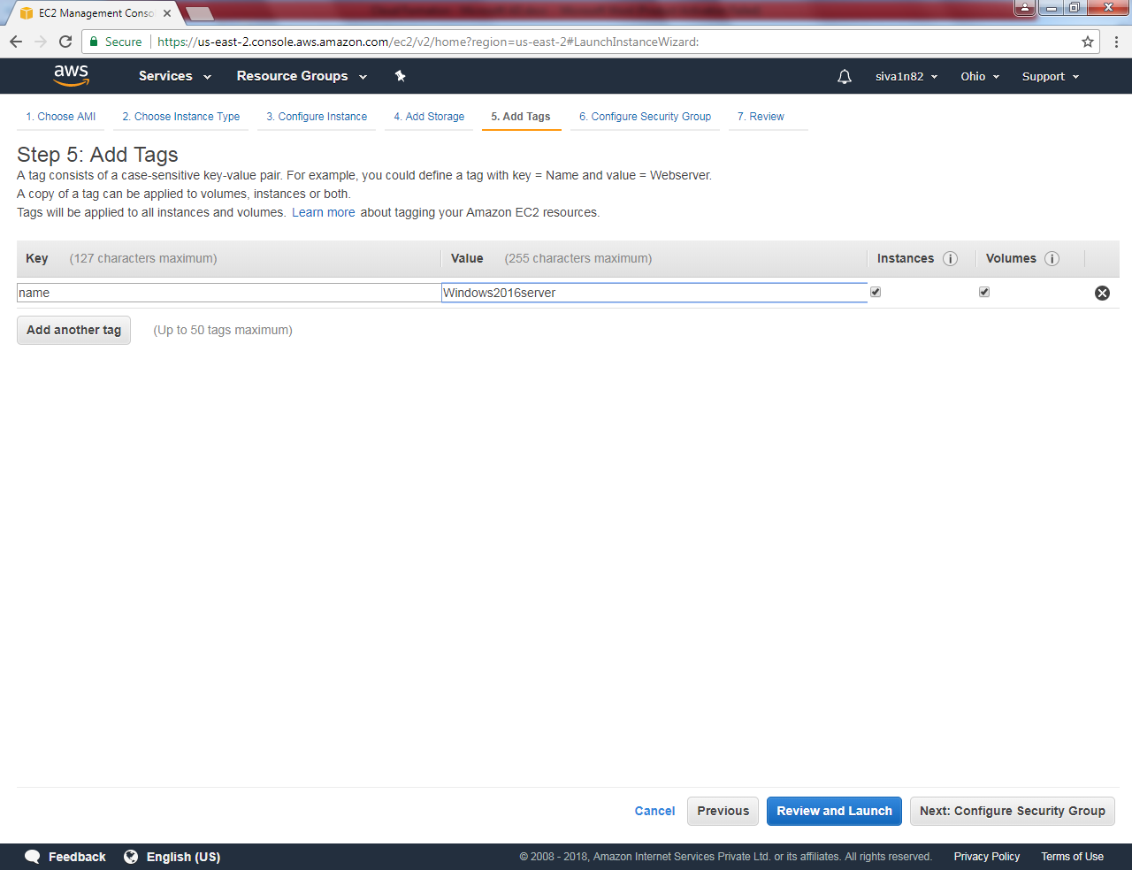

Click ”Next”.

Need to select the “Domain members” Security group.

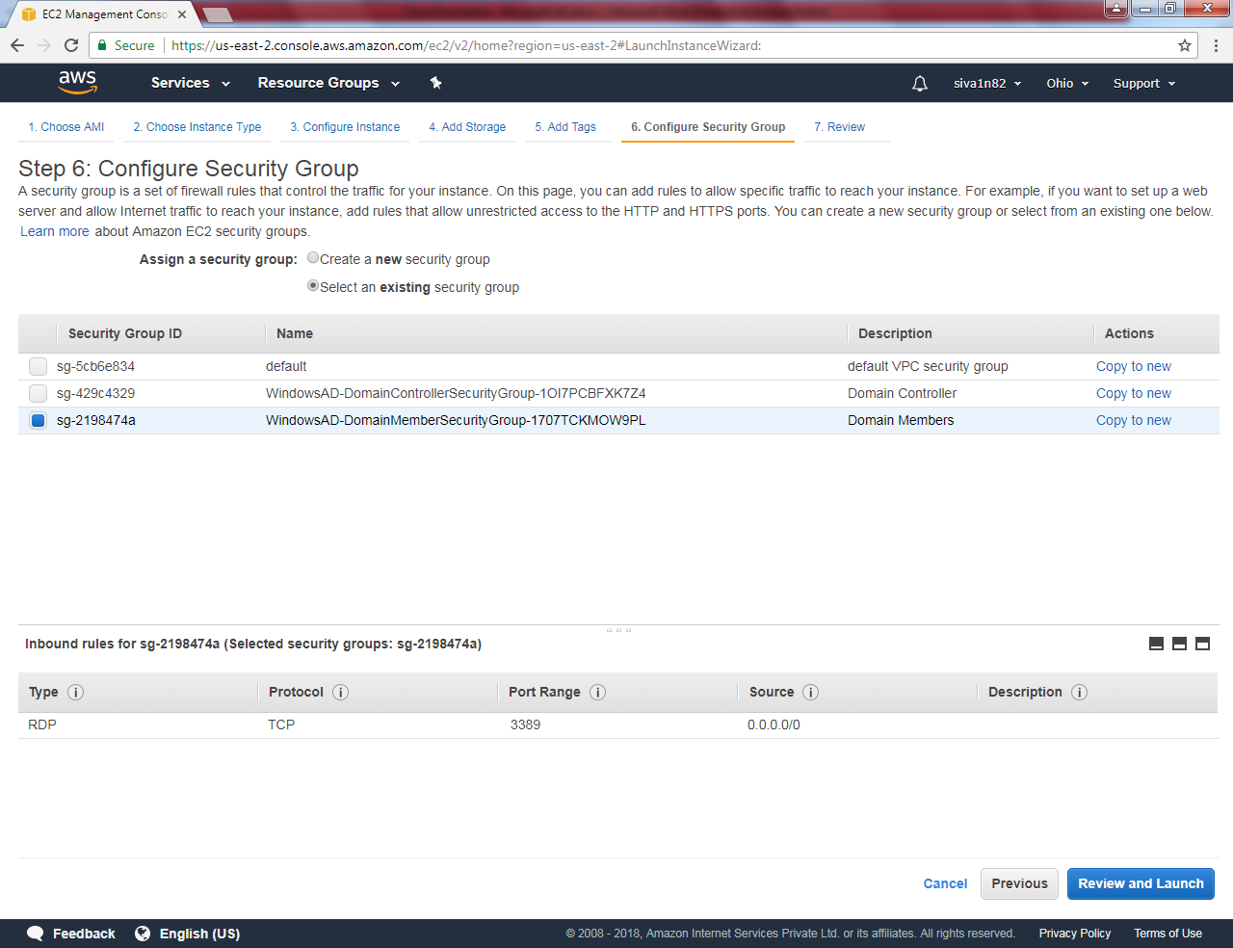

Click “Review and Launch”.

Click “Launch”.

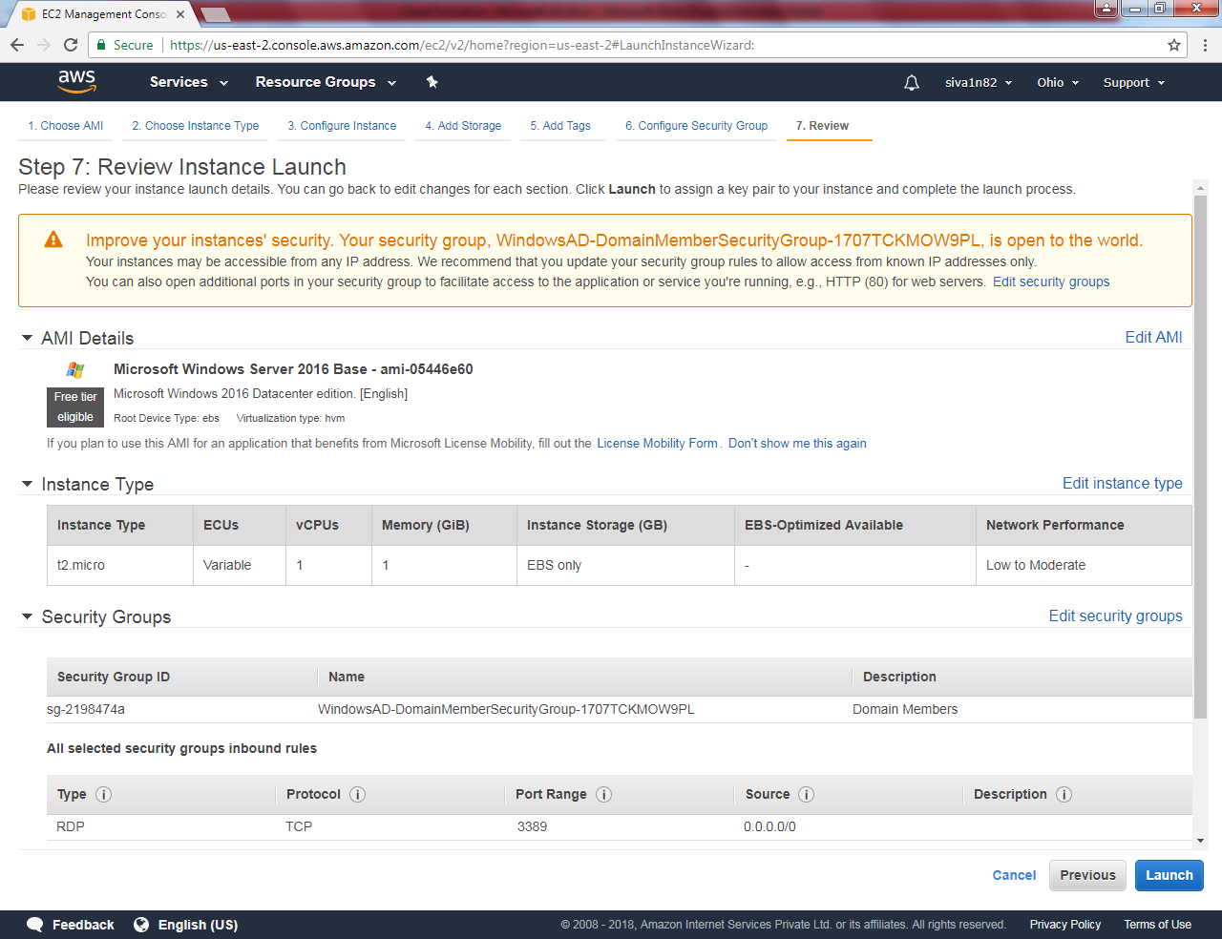

Click “Launch Instances”.

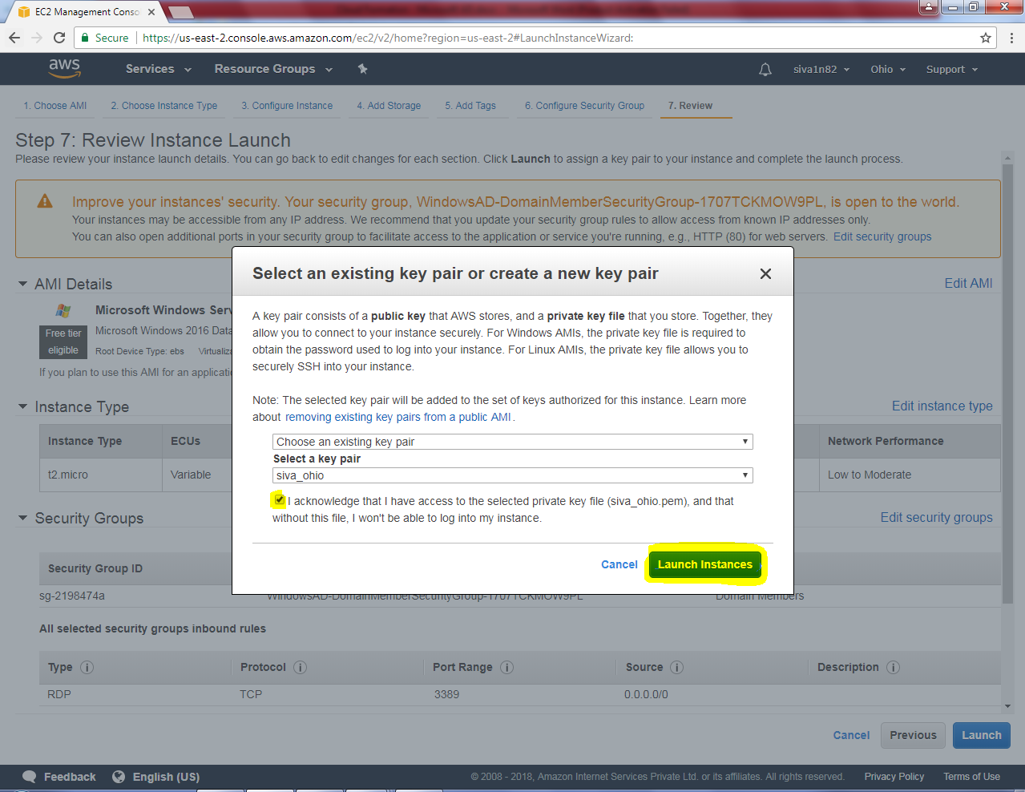

Click member server and then click “Connect “to get login credentials of the server.

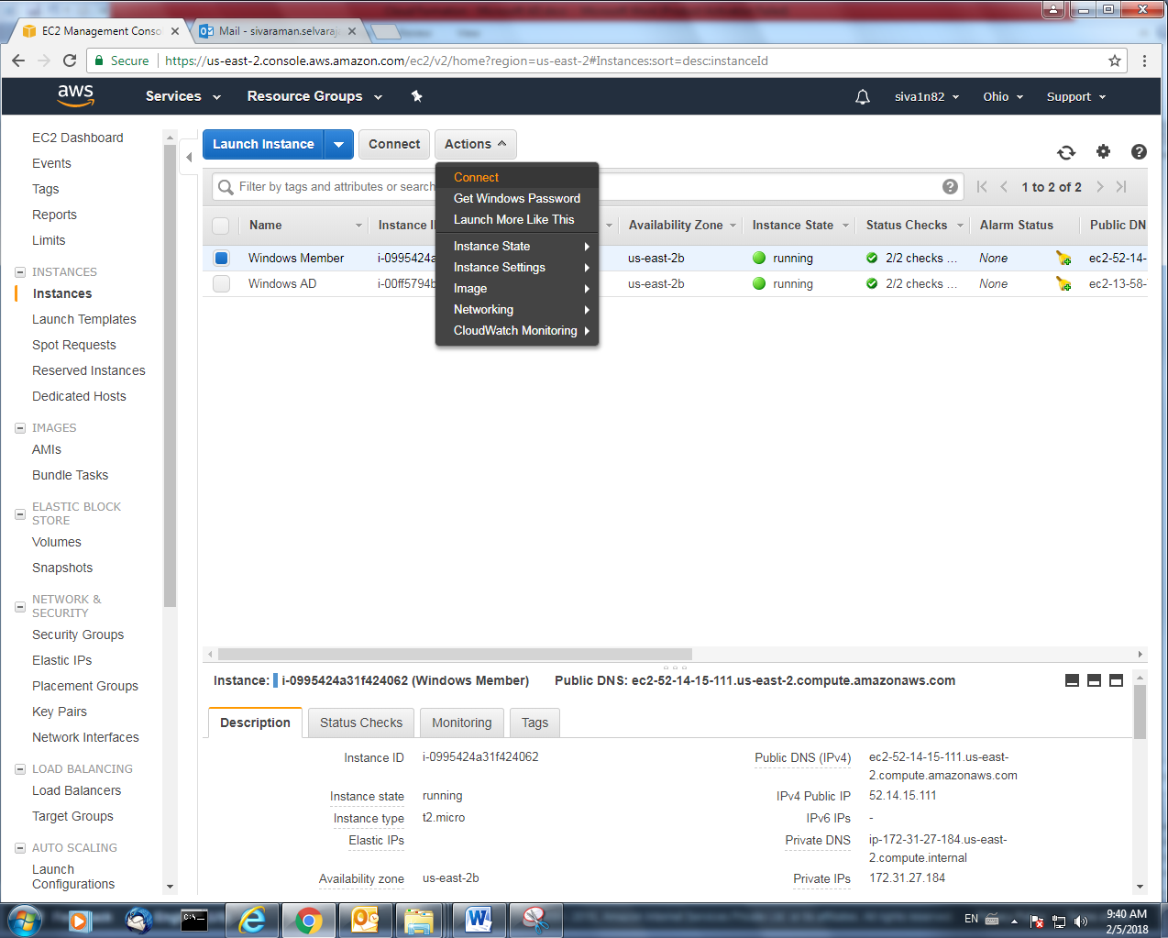

Choose the *.pem file and click Decrypt password.

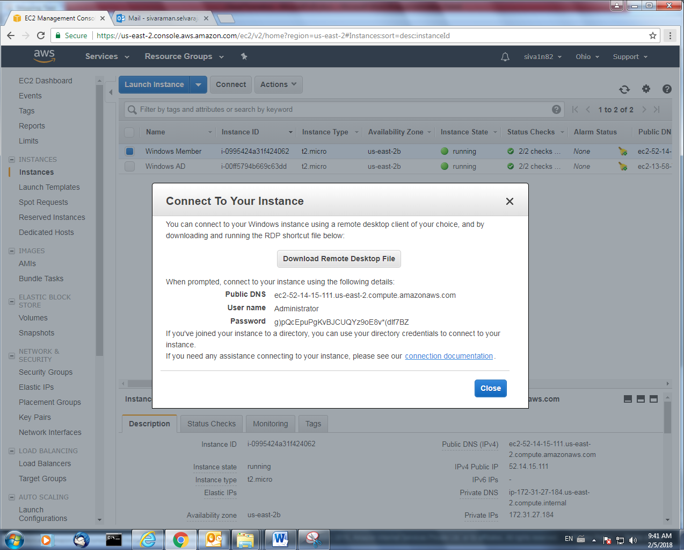

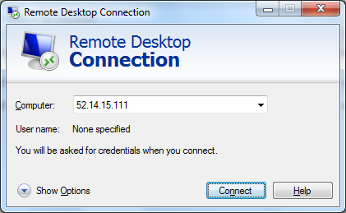

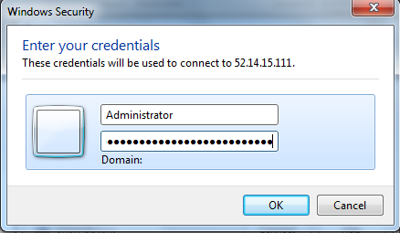

Right click “Start” menu of member server. Then click “Run”.

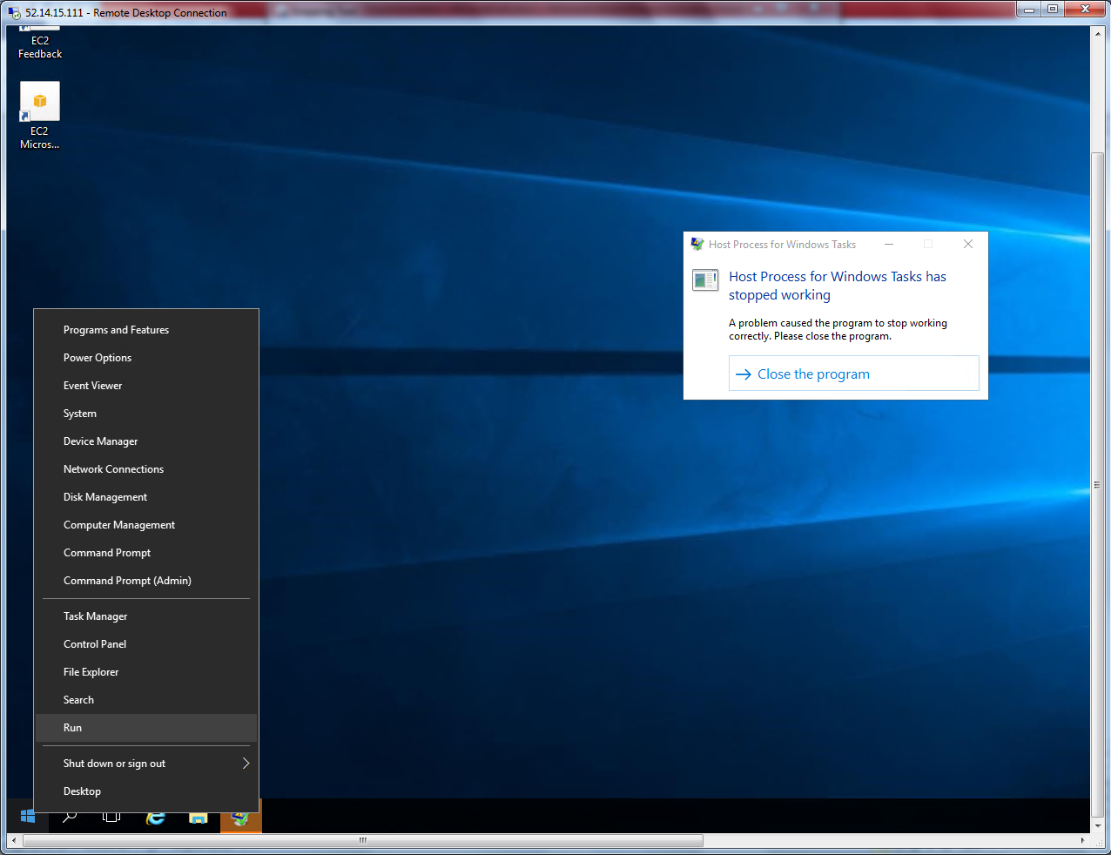

Type ncpa.cpl

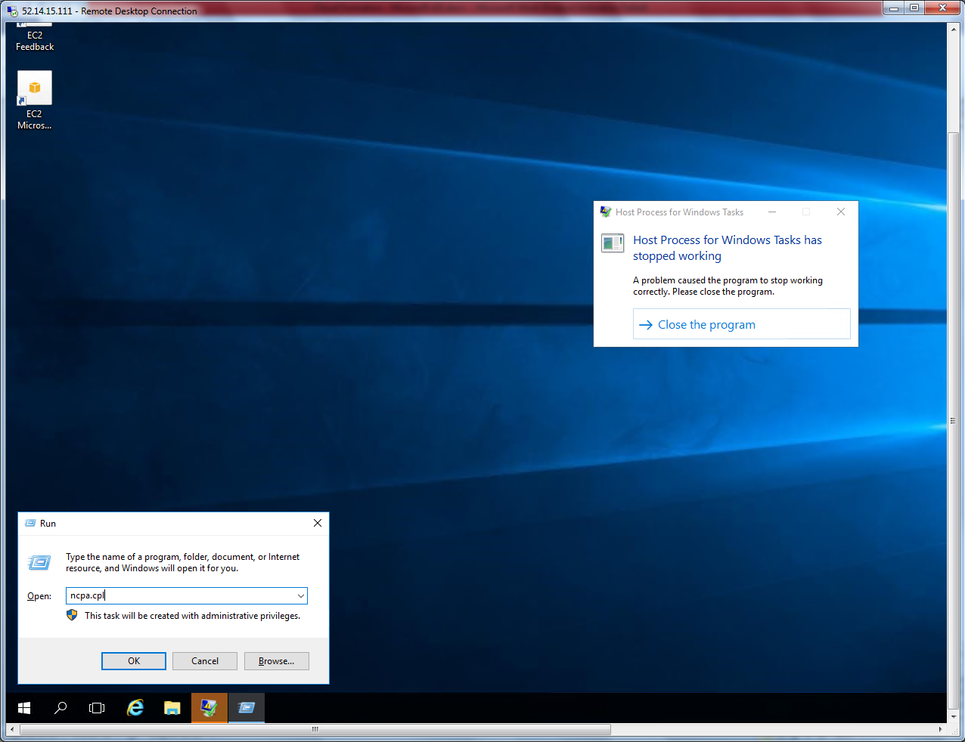

In Network card right click.

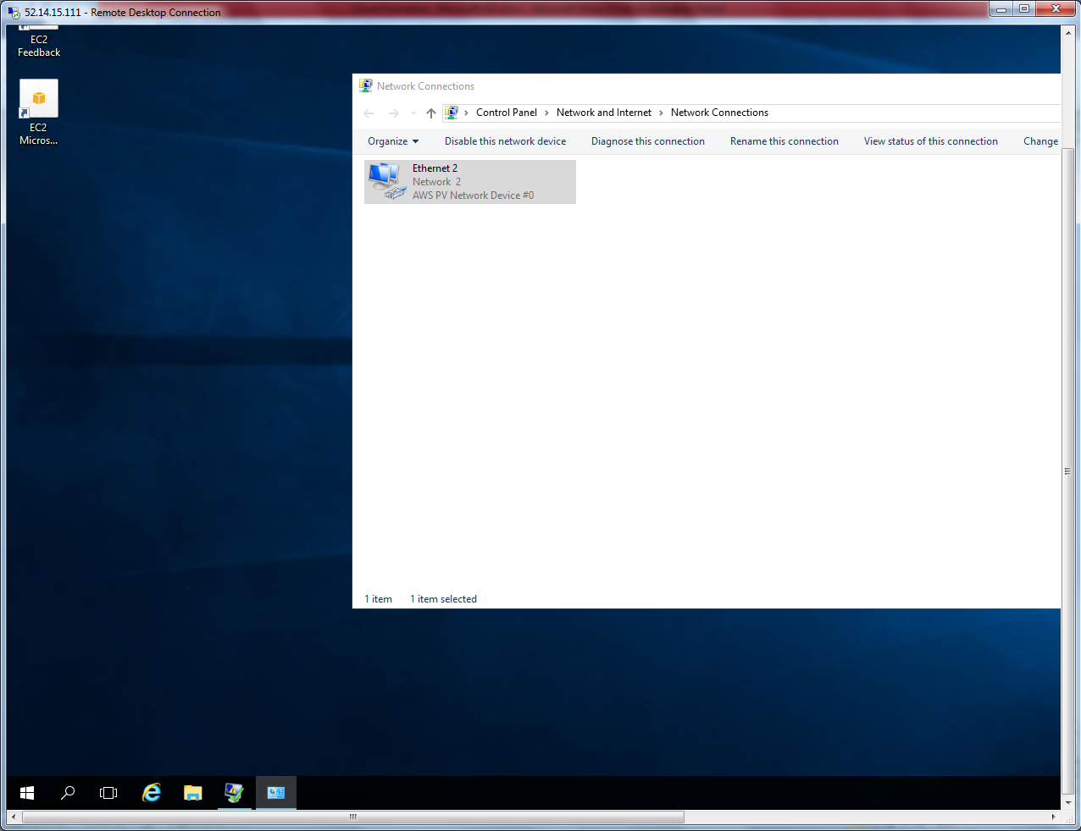

Select properties.

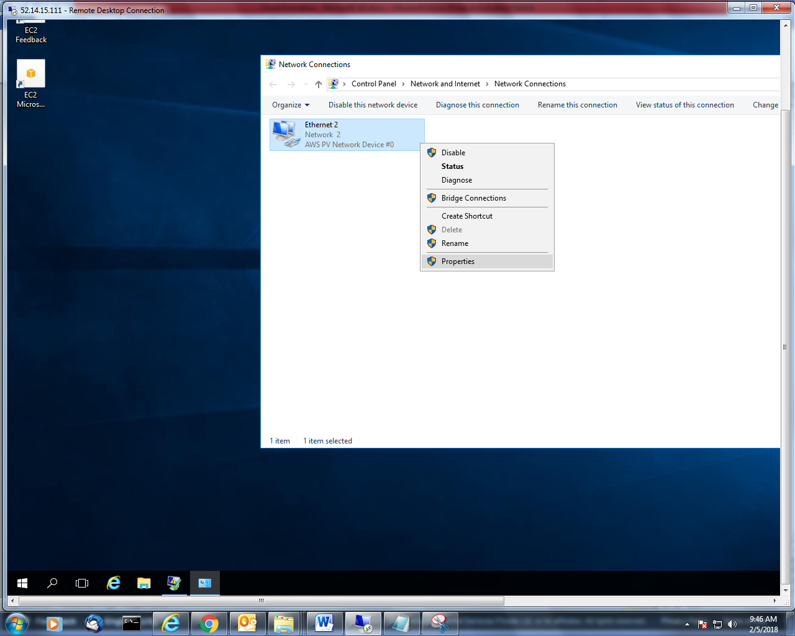

Type the DC IP address i.e. 172.31.31.145 and click “Ok”.

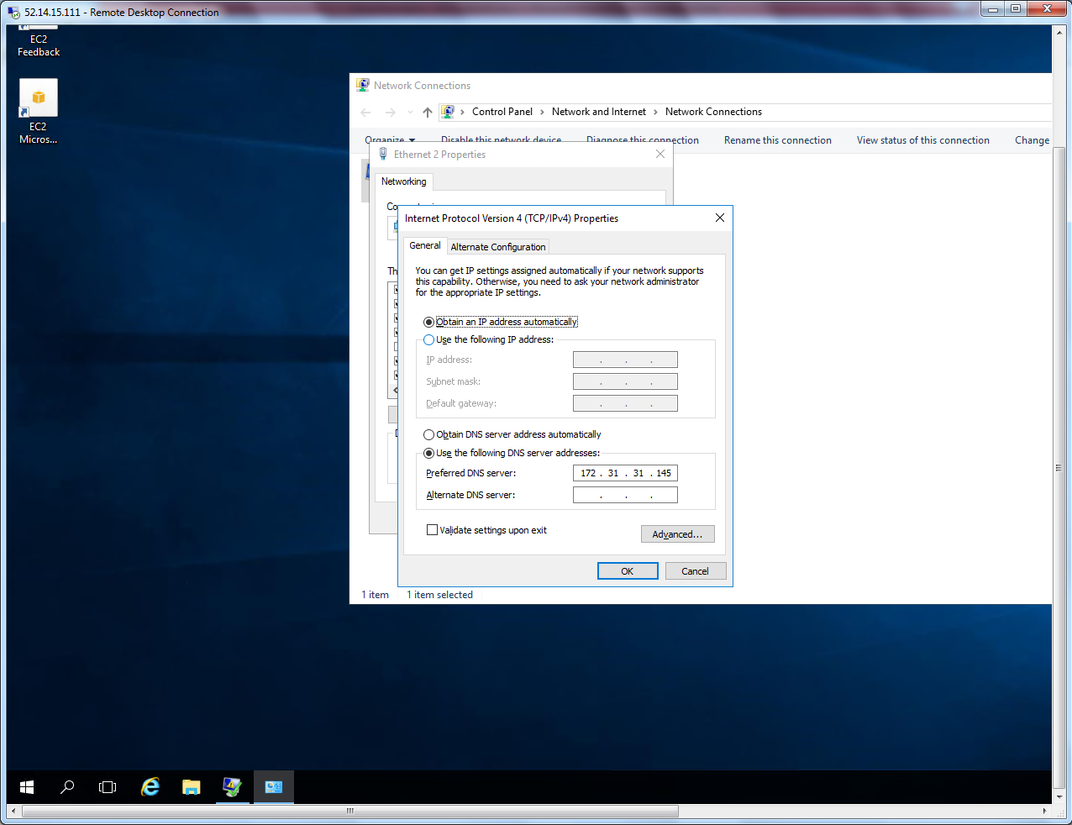

Click “Ok”.

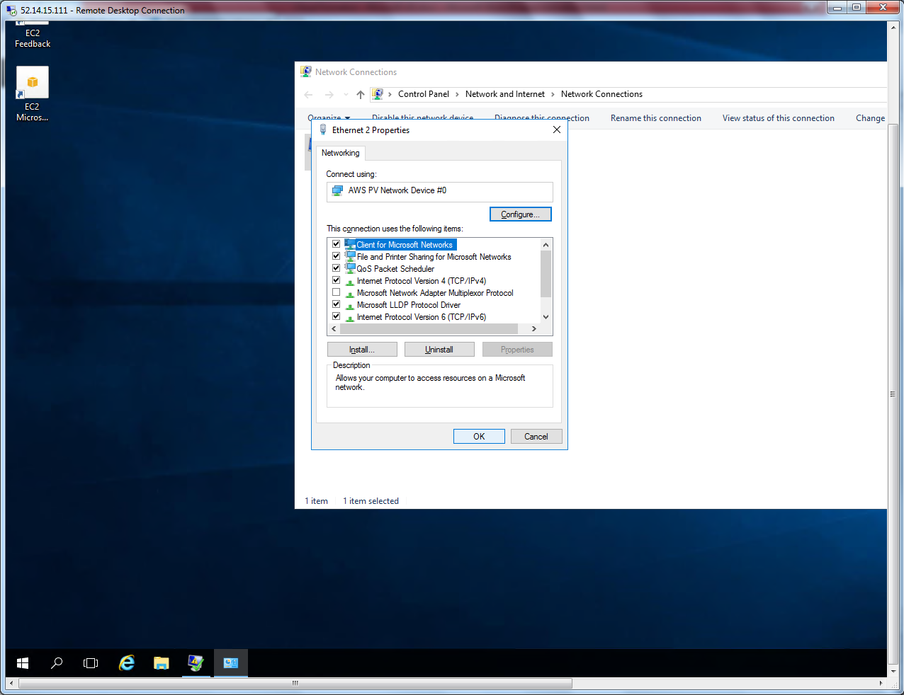

Try to connect DC server

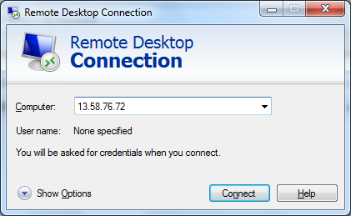

Select Domain controller, click Actions 🡪 Connect to get password.

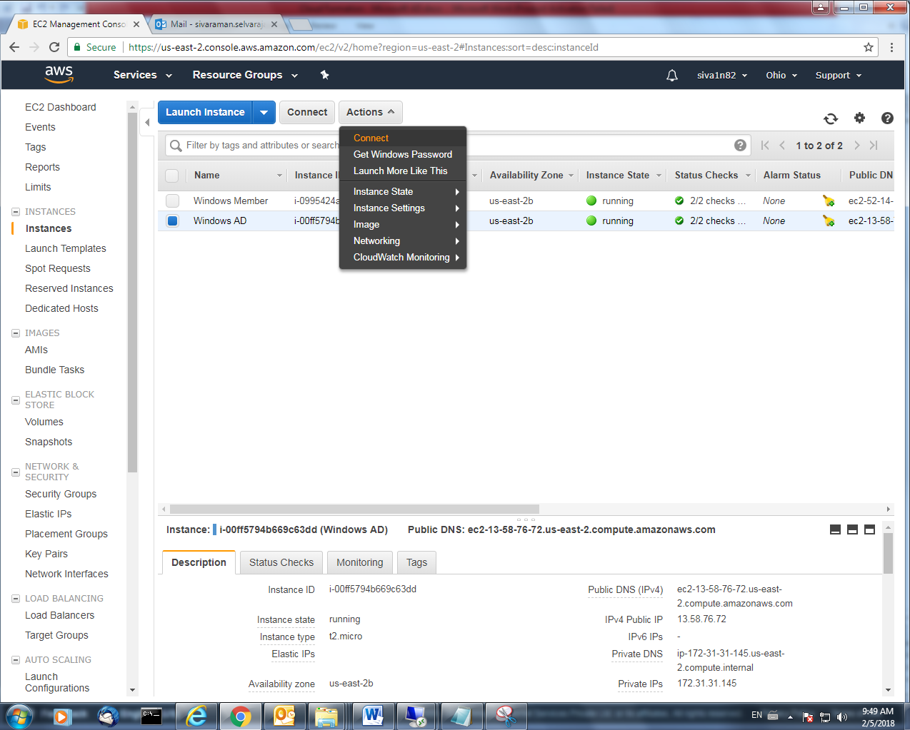

Click “Get password”.

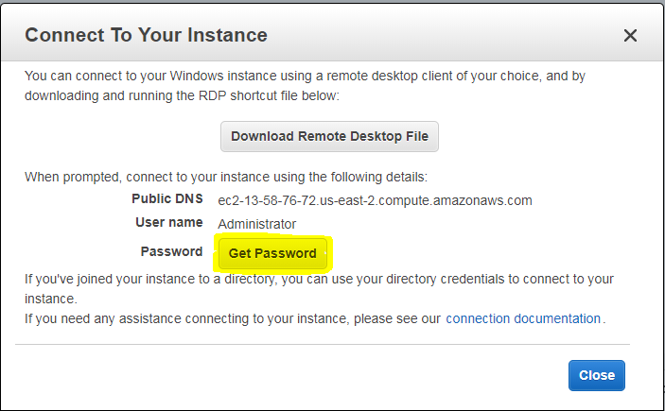

Choose the *.pem file

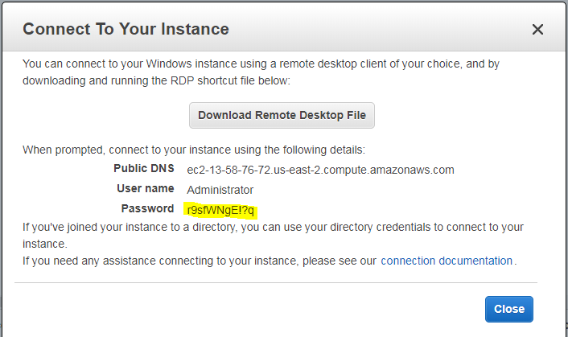

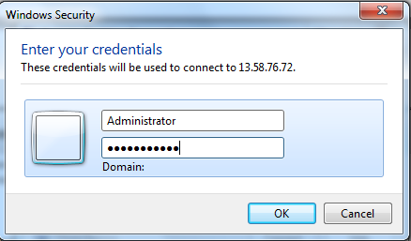

Type dsa.msc to get active directory console.

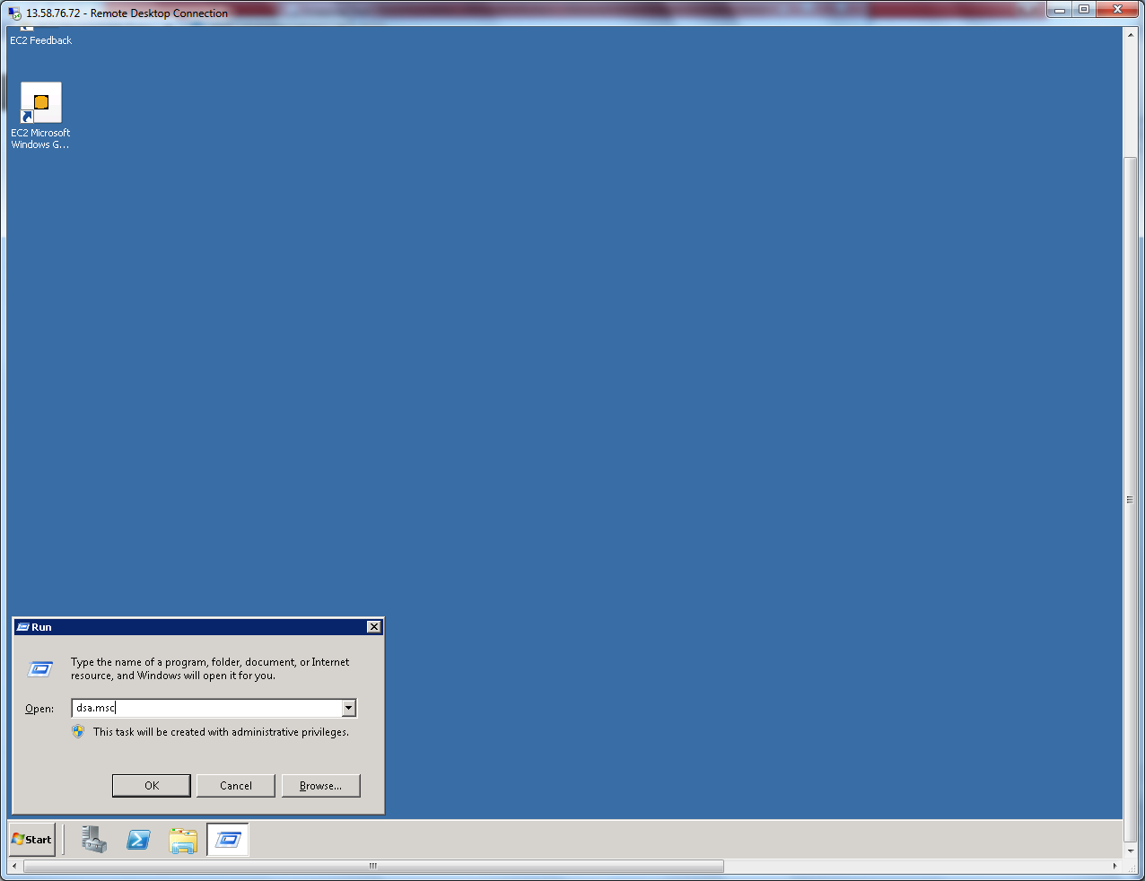

Click “Users”.

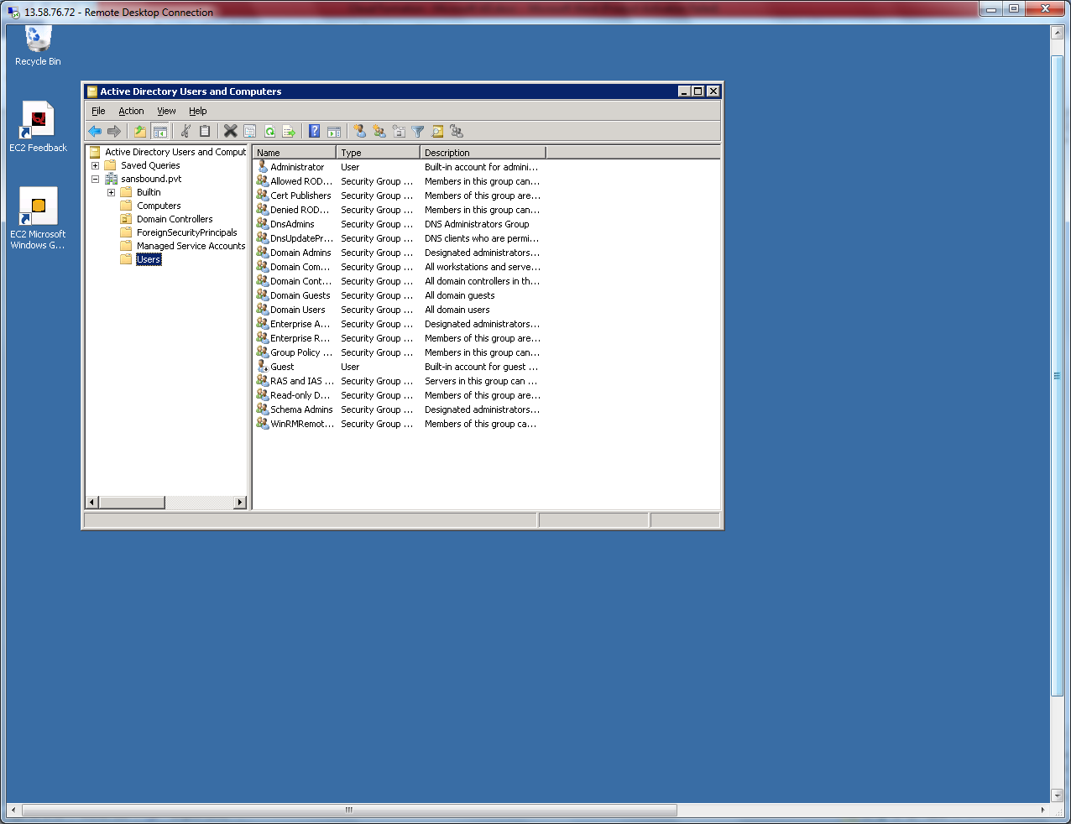

Right click and then click new 🡪 User

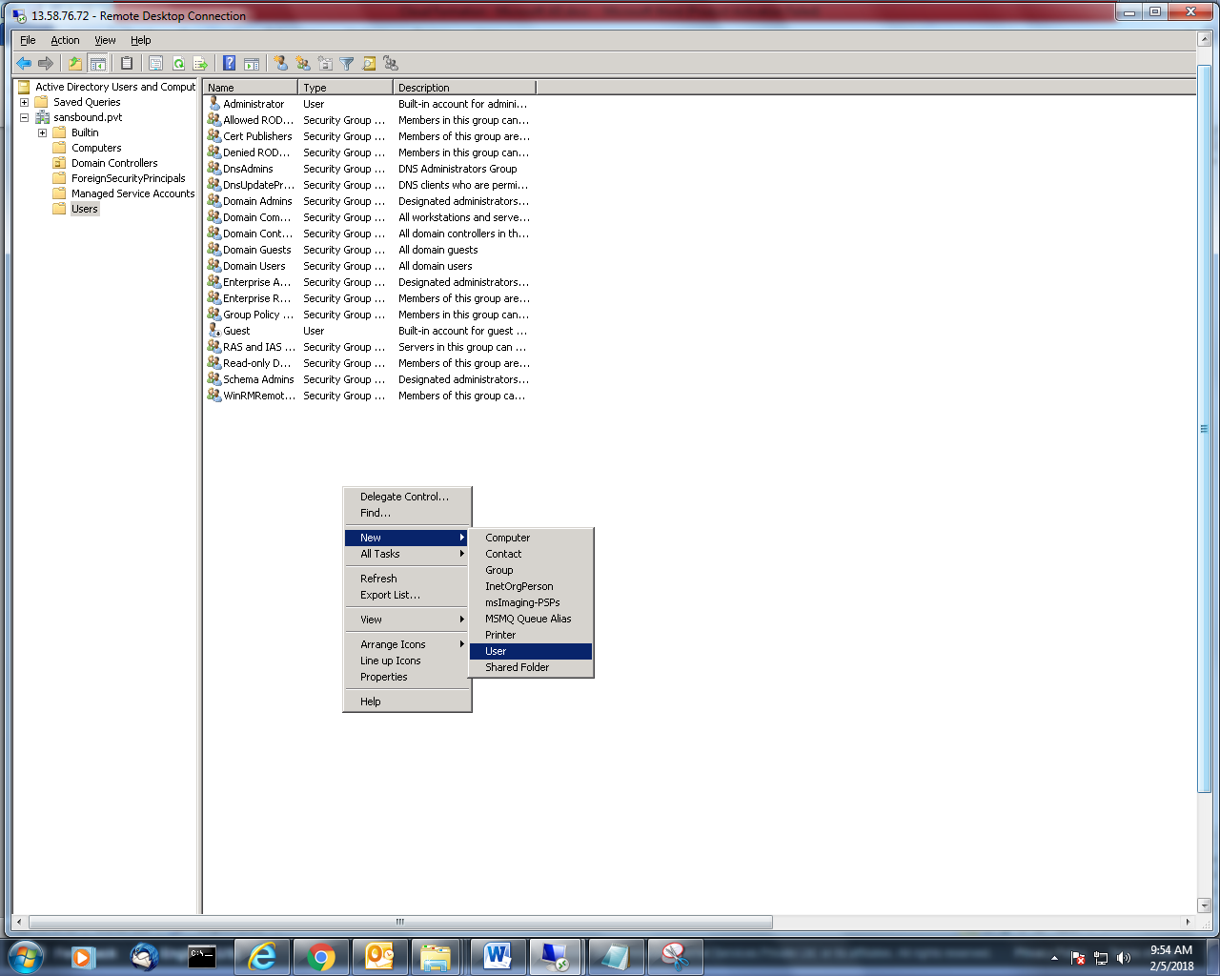

Type the username as student1 and click “Next”.

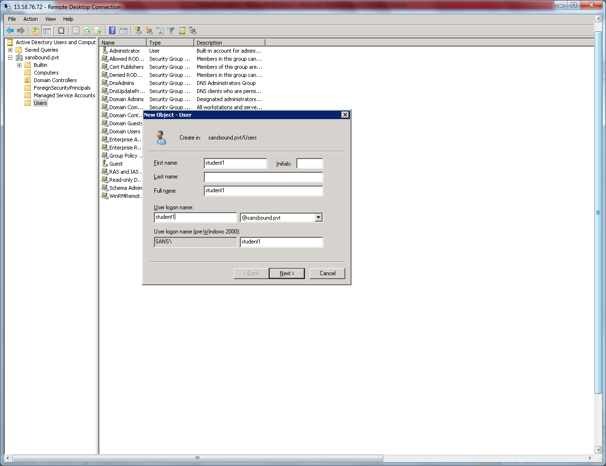

Type the password of Student1 and then click “Next”.

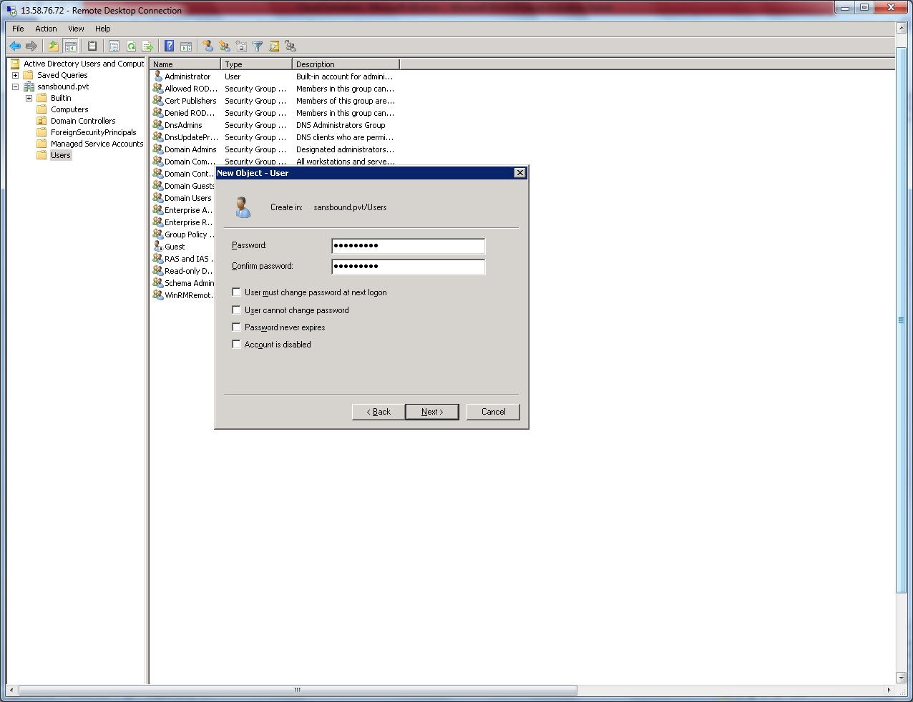

Click “Finish” to create.

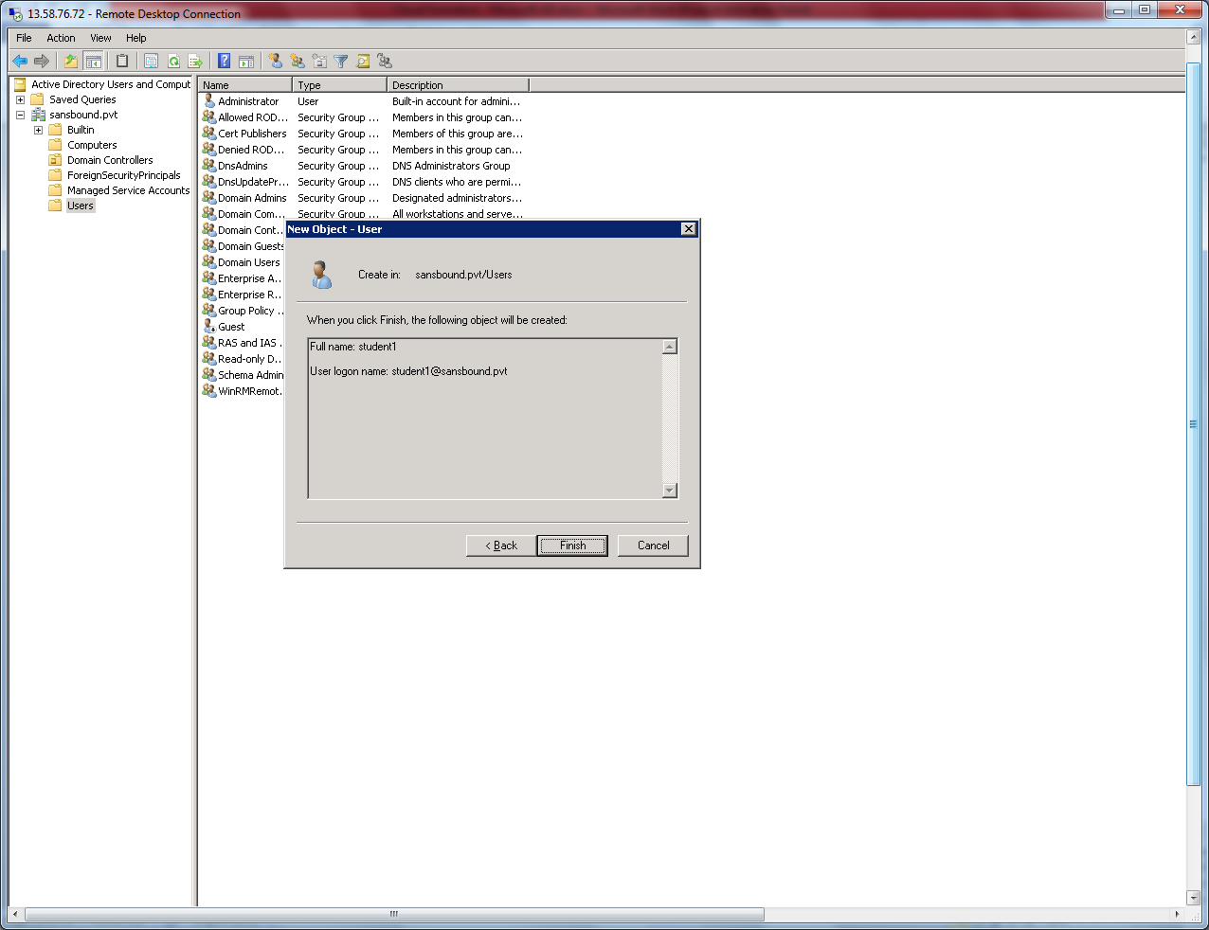

User has been created successfully. Now right click username and click properties.

Then click “Member of” tab.

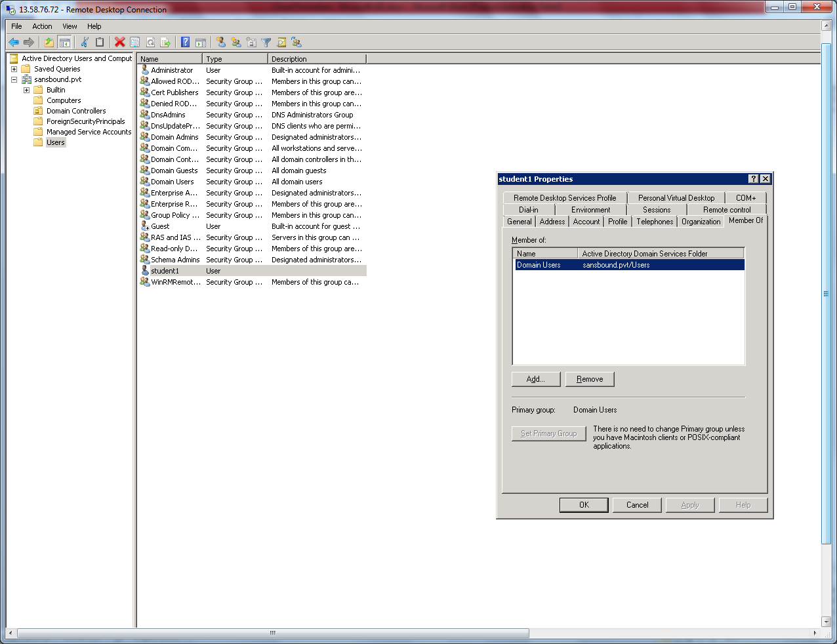

Go to member Server,

Right click the start menu and click ‘System”.

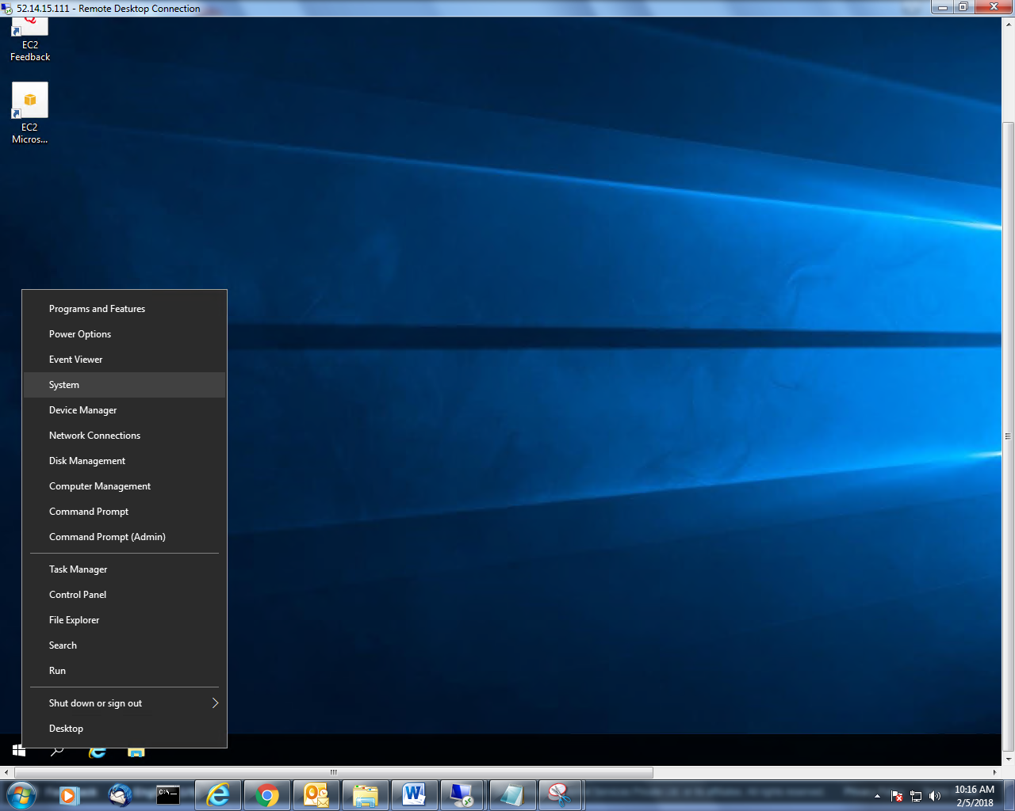`

Click “Change settings”.

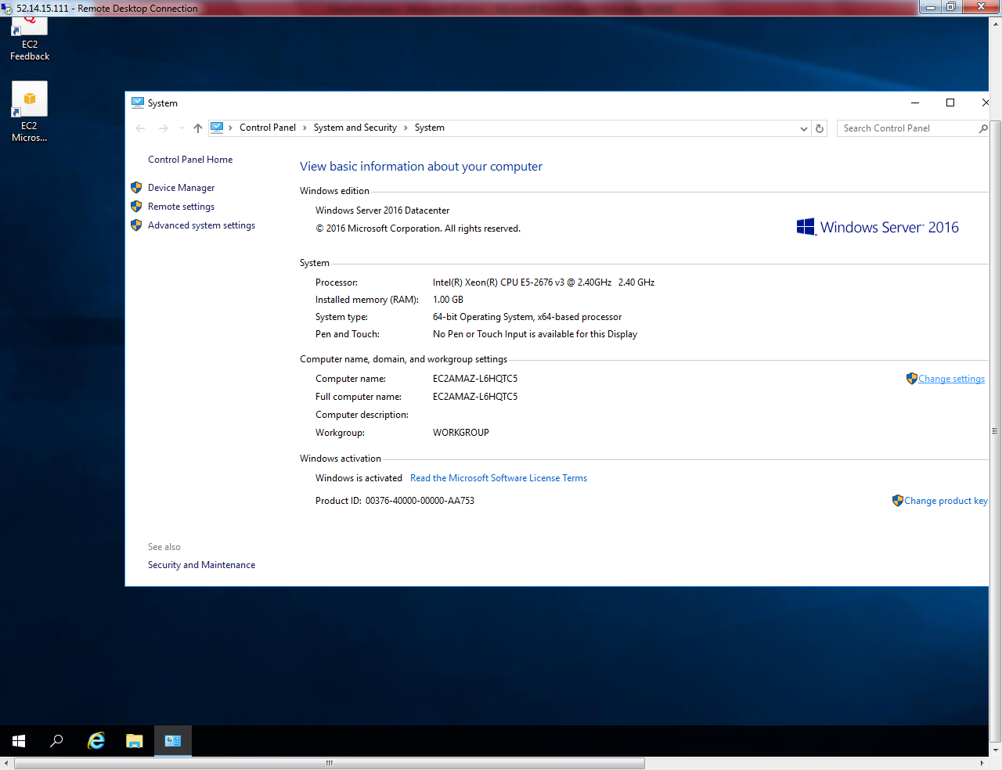

Click “Change”.

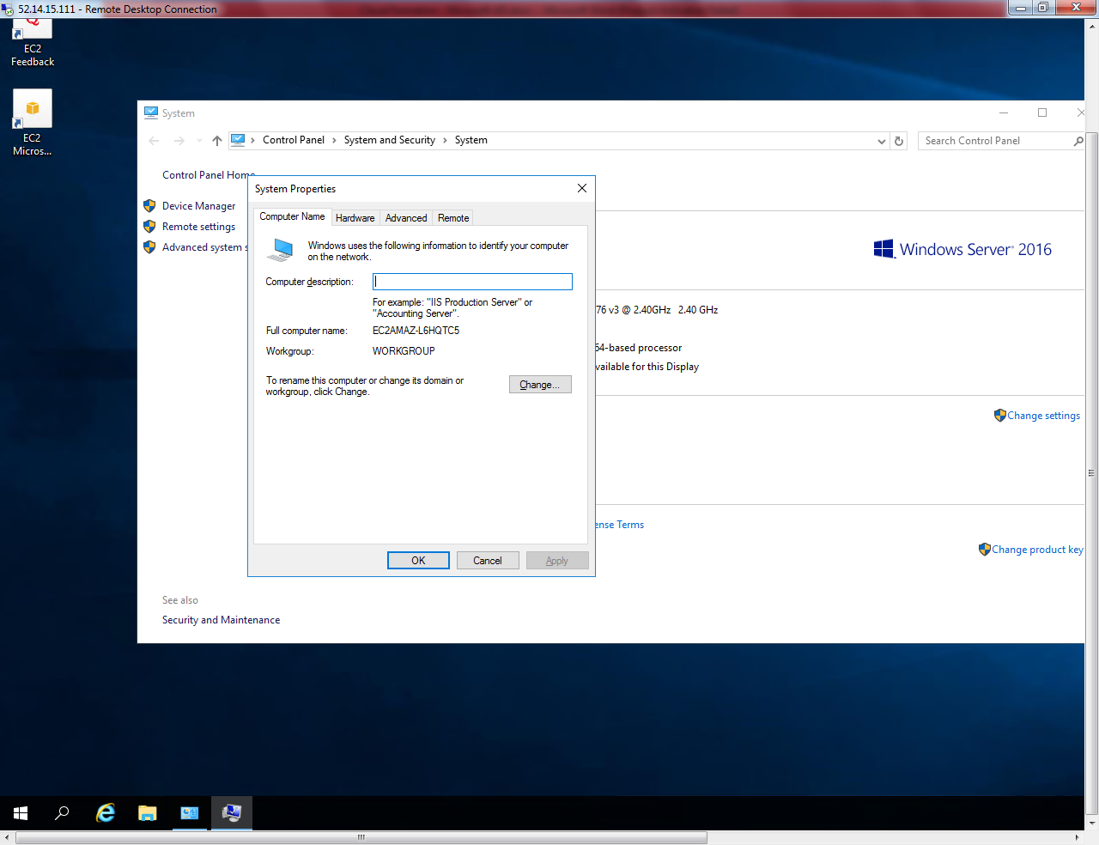

Click “More”.

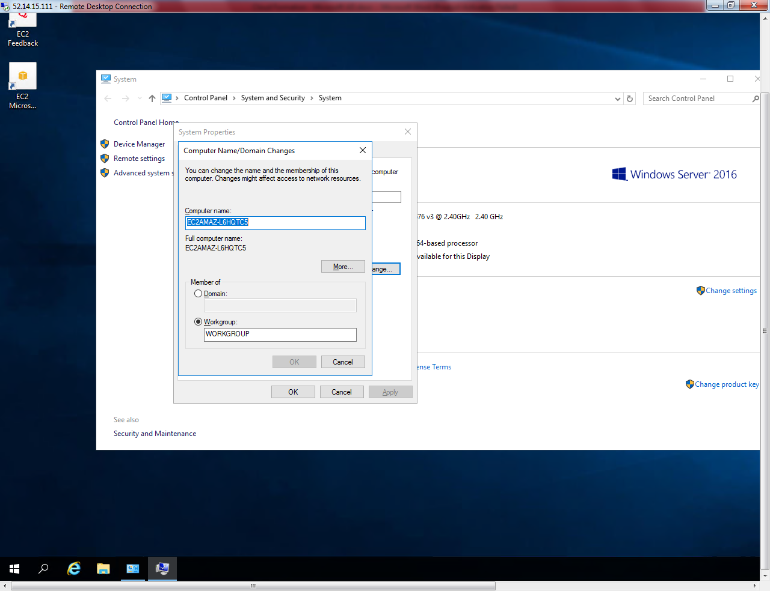’

Type “sansbound.pvt”

Then click “Ok”.

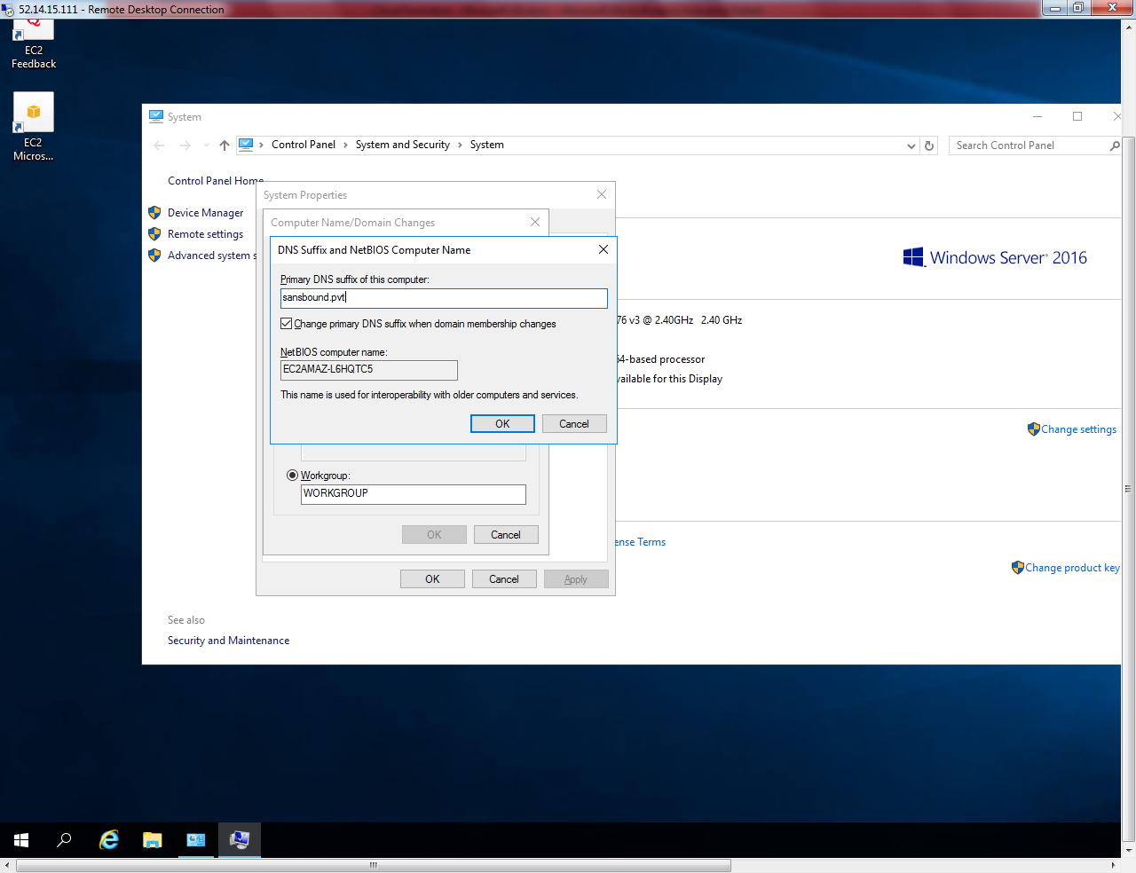

Click “Domain”and then type sansbound.pvt .

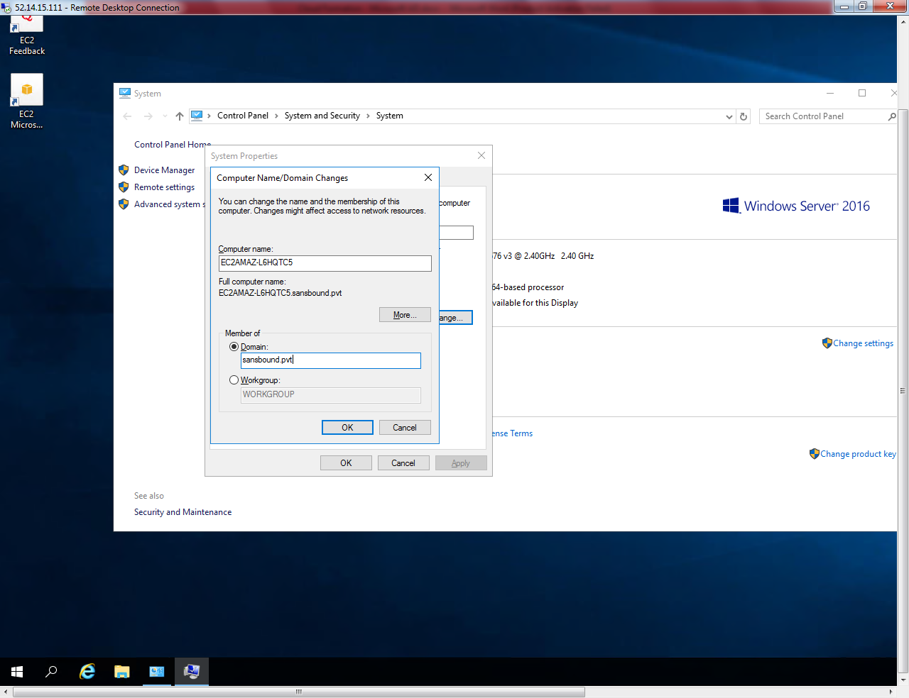

Click “Ok”.

Type the username password of Student1 to join the system to domain.

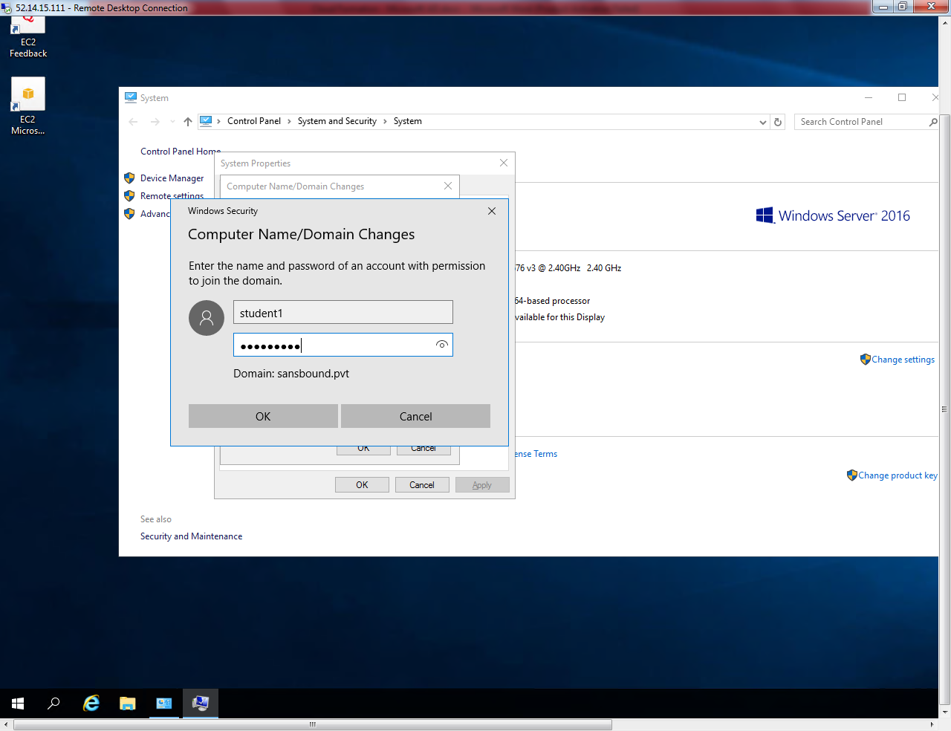

Now system has been successfully joined to domain.

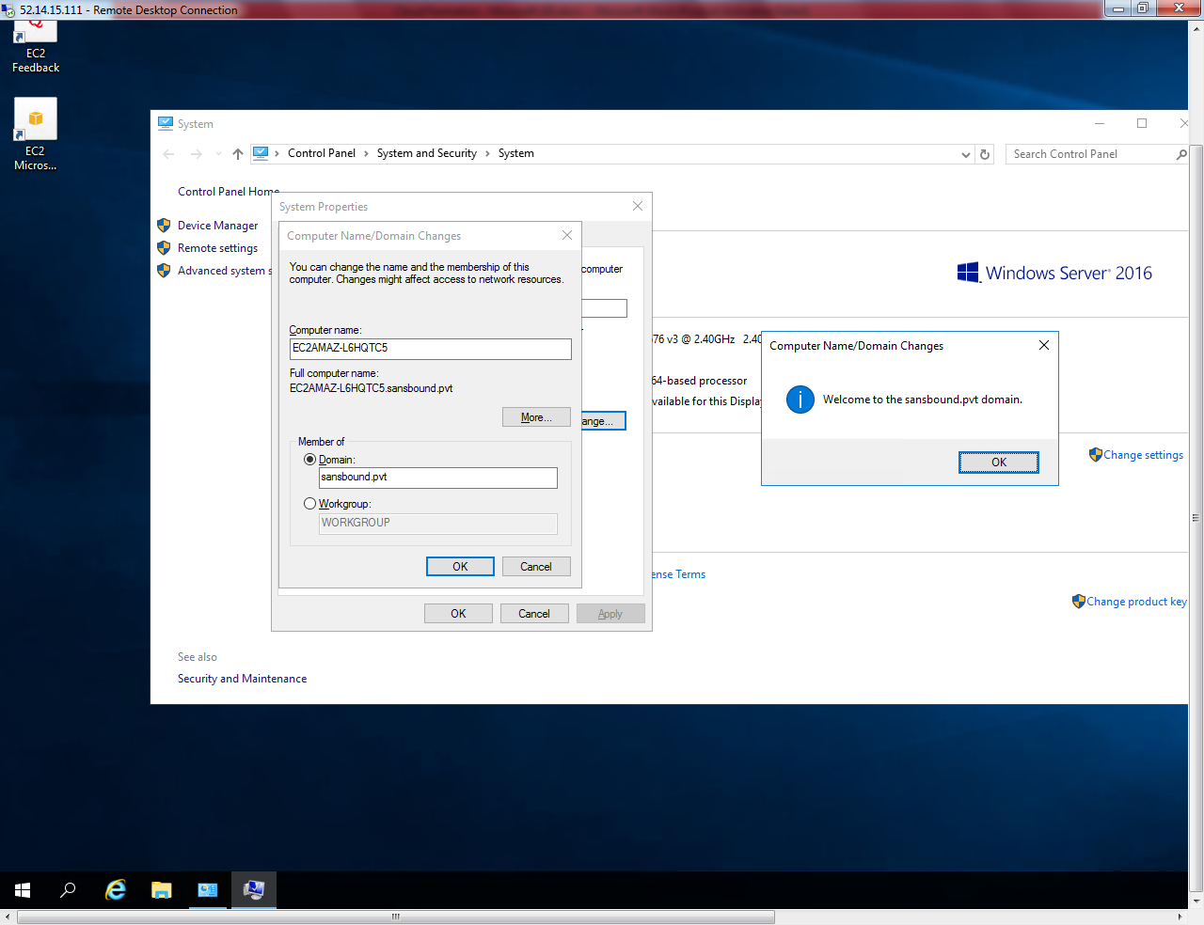

Click “Ok”.

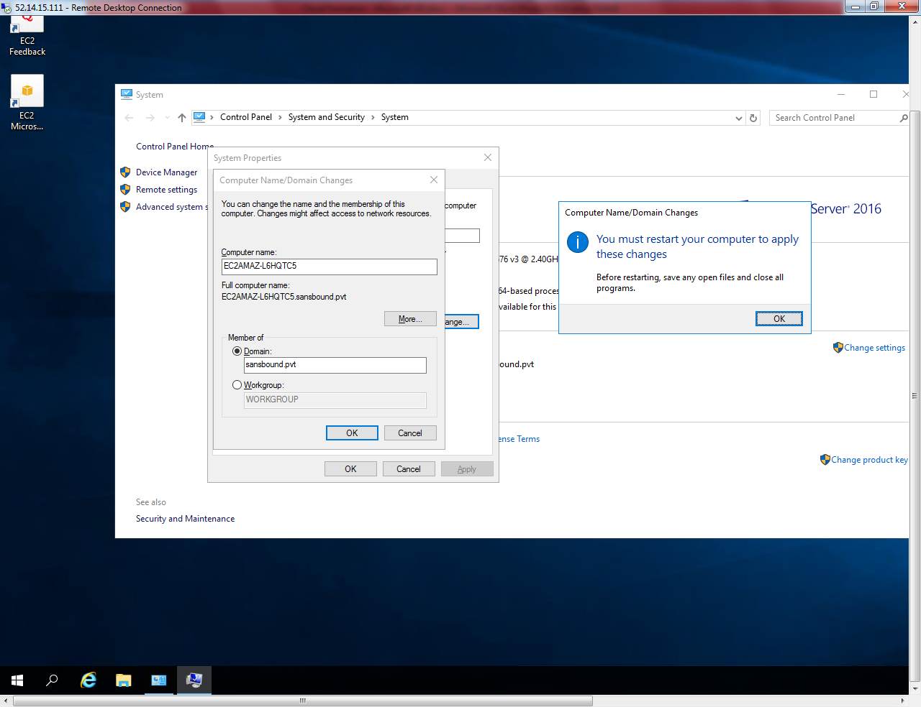

Click “Close”.

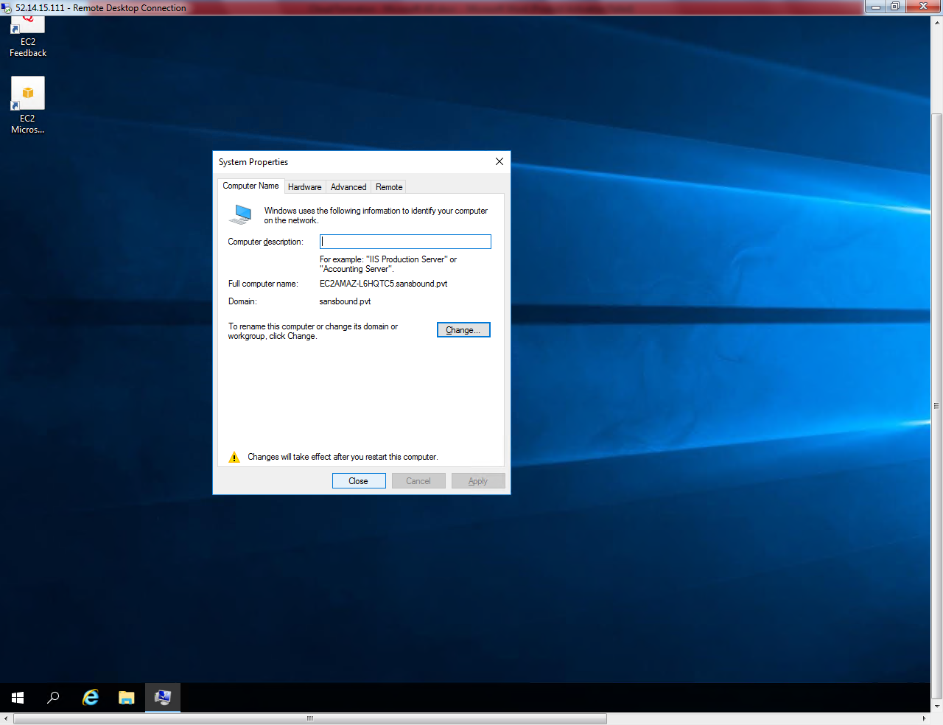

Click “Restart now”.

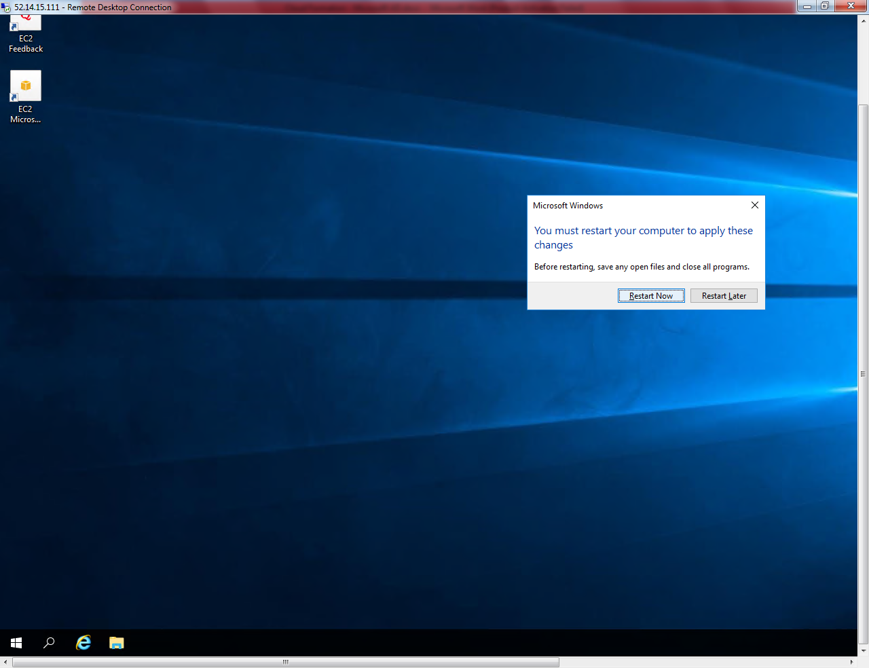

Now try to connect the member server with domain user (student1) login credentials.

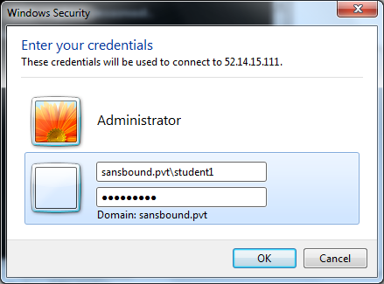

Serve has refused that the connection was denied because the user account is not authorized for remote login.

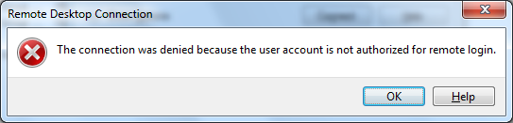

What could be cause of this issue?

We need to add user to “Allow remote connection to this computer” option.

Right click the start menu and then click “System”.

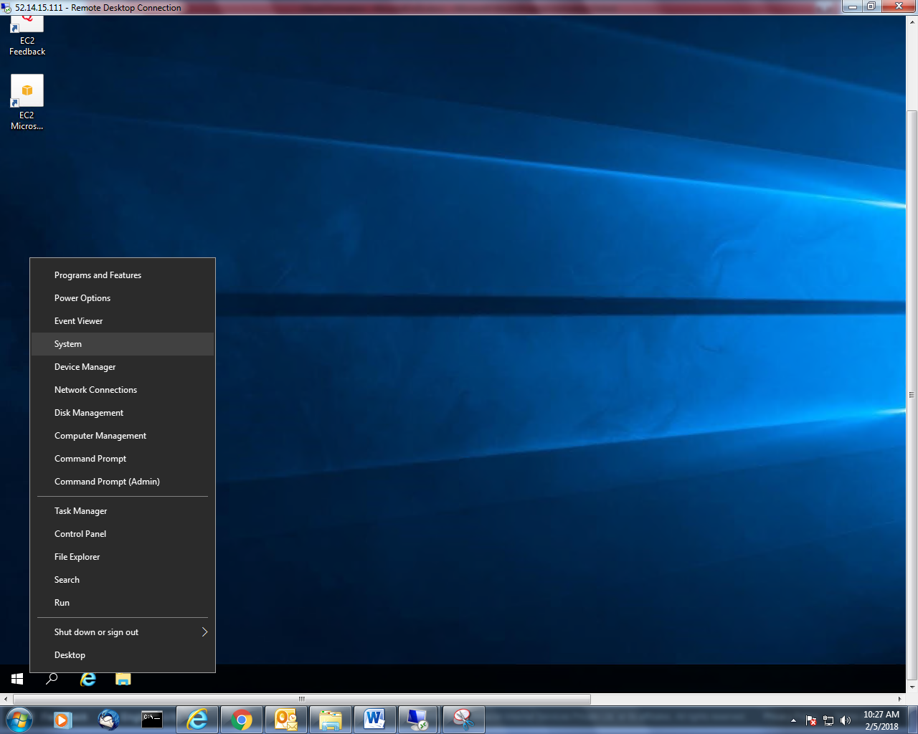

Click “Remote settings”.

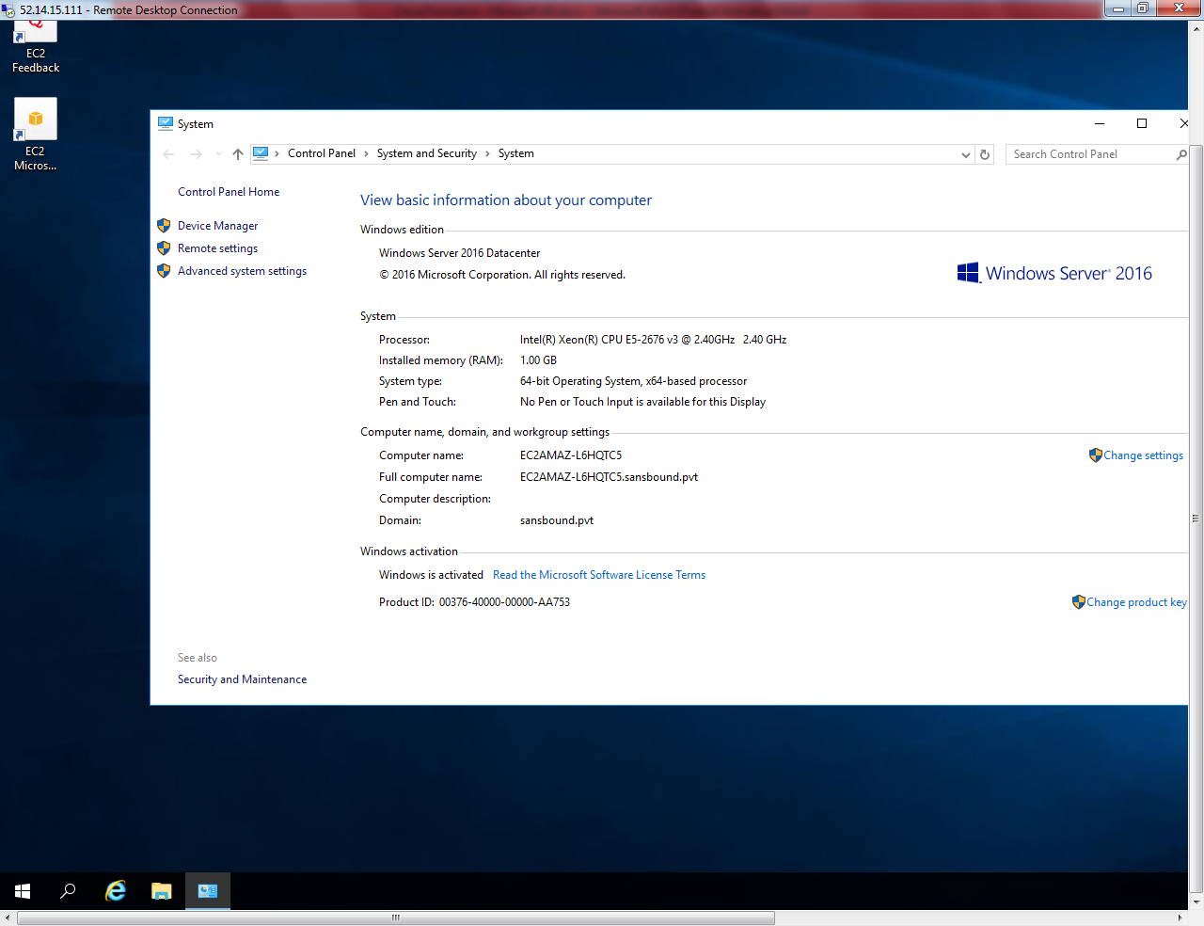

Click “Select users”.

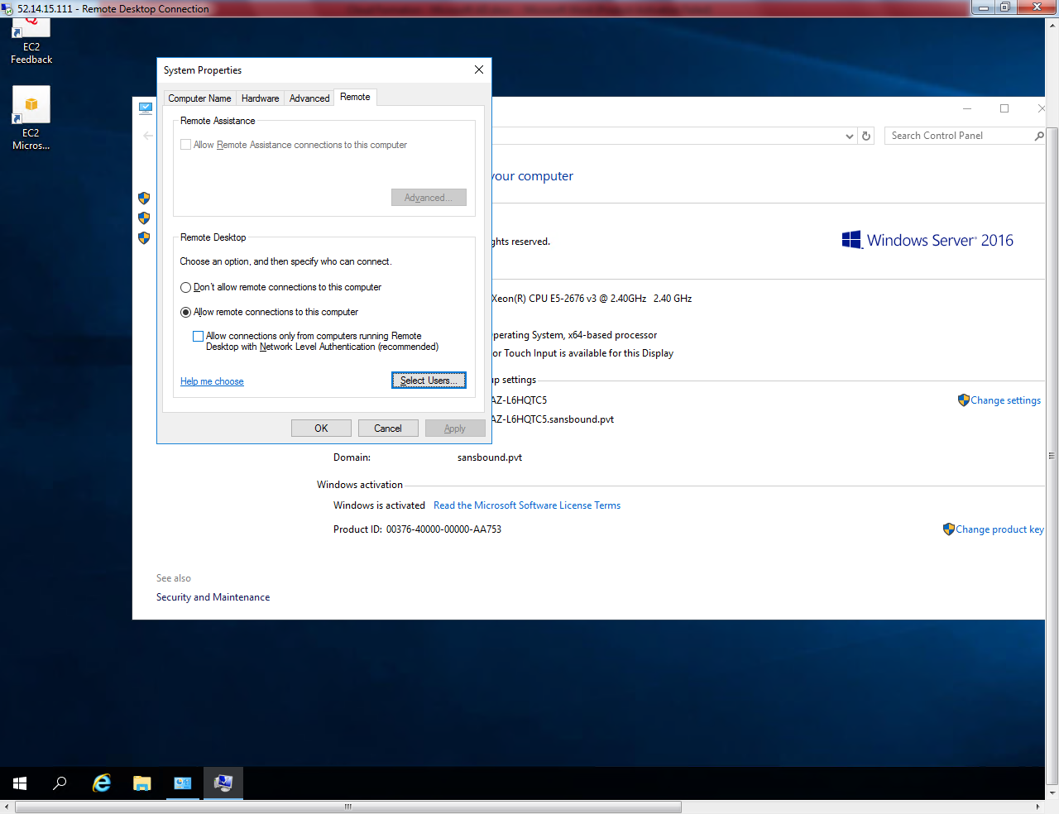

Click “Add”.

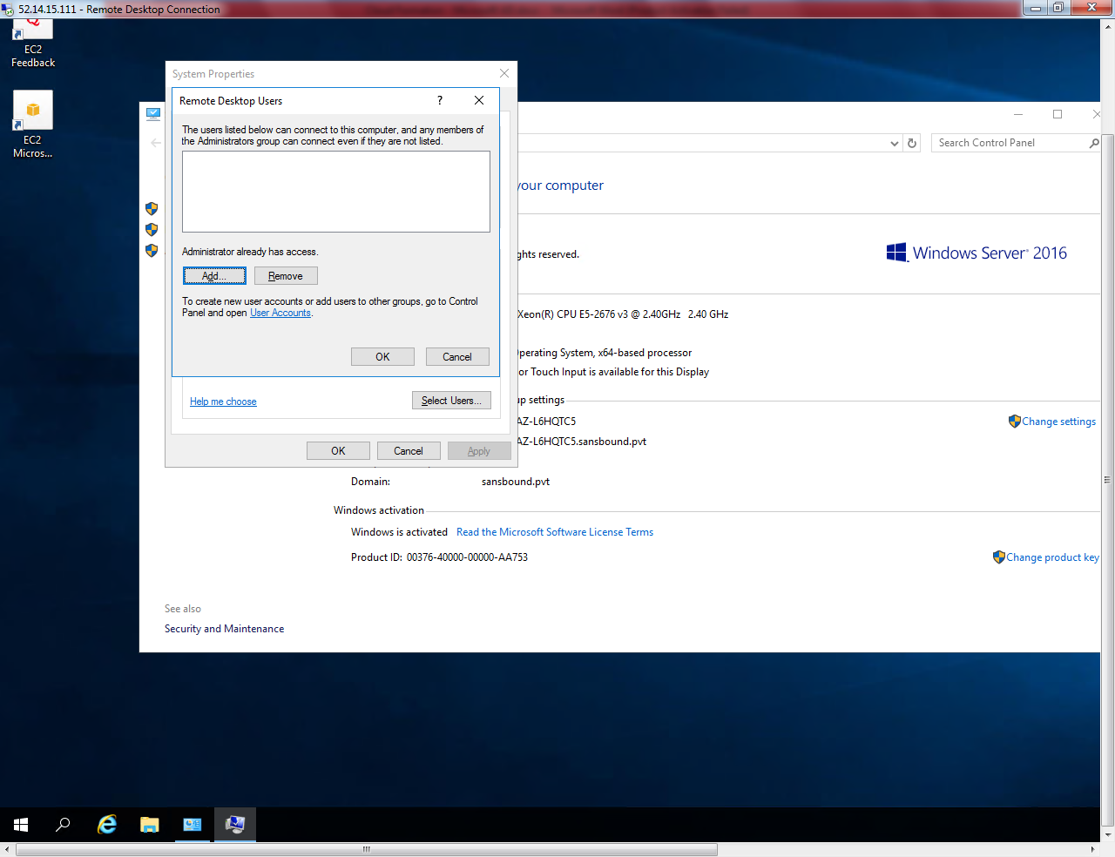

Type the domain admin privilege user to list the use detail.

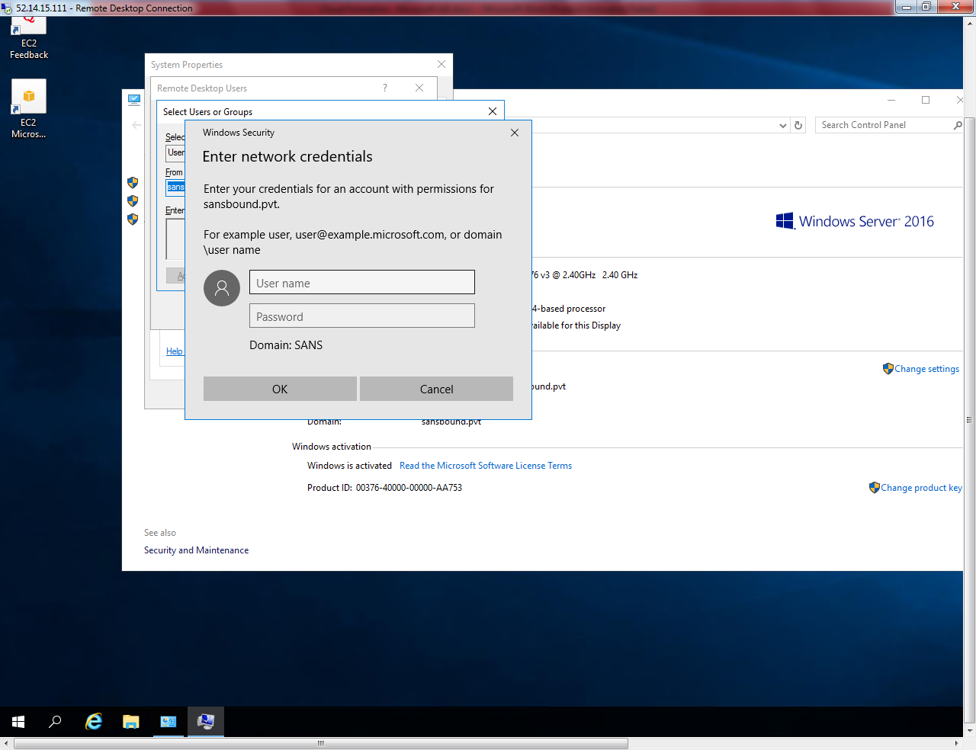

Click “Ok”.

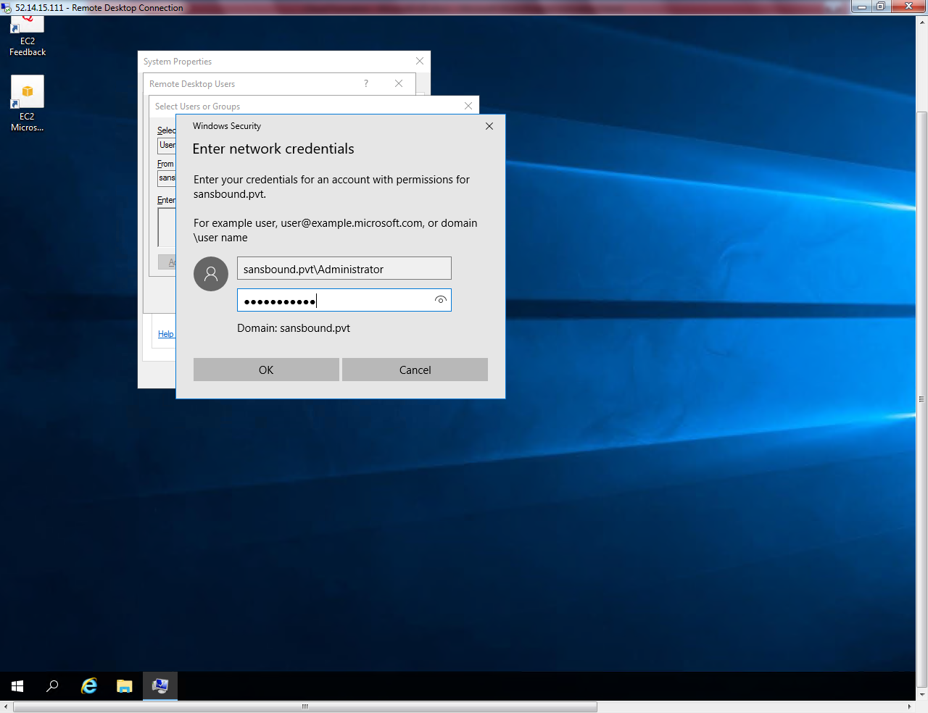

Click “Find now”.

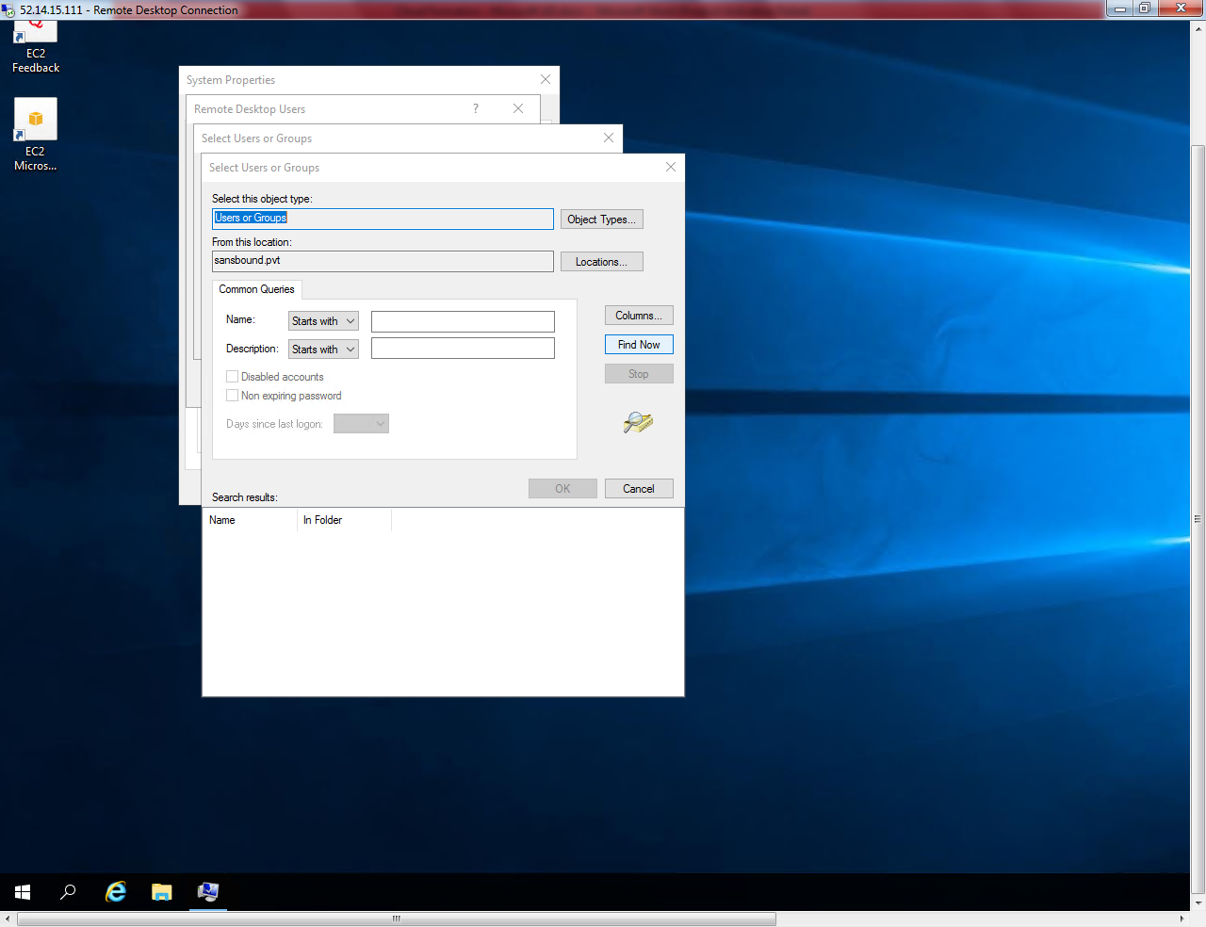

If it requires login credentials please type domain admin privilege password to get below option.

Type the user student1 and click Find now.

Then click “Ok”.

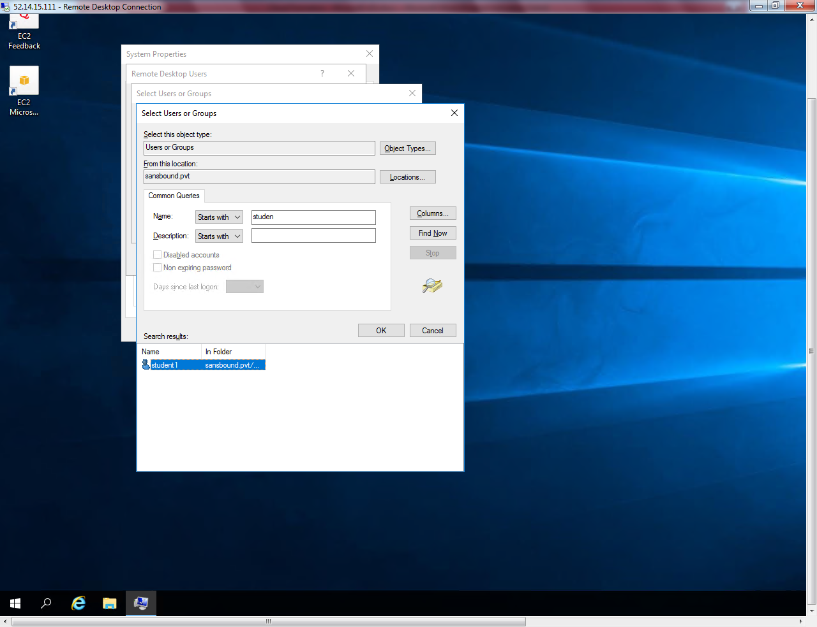

Click “Ok”.

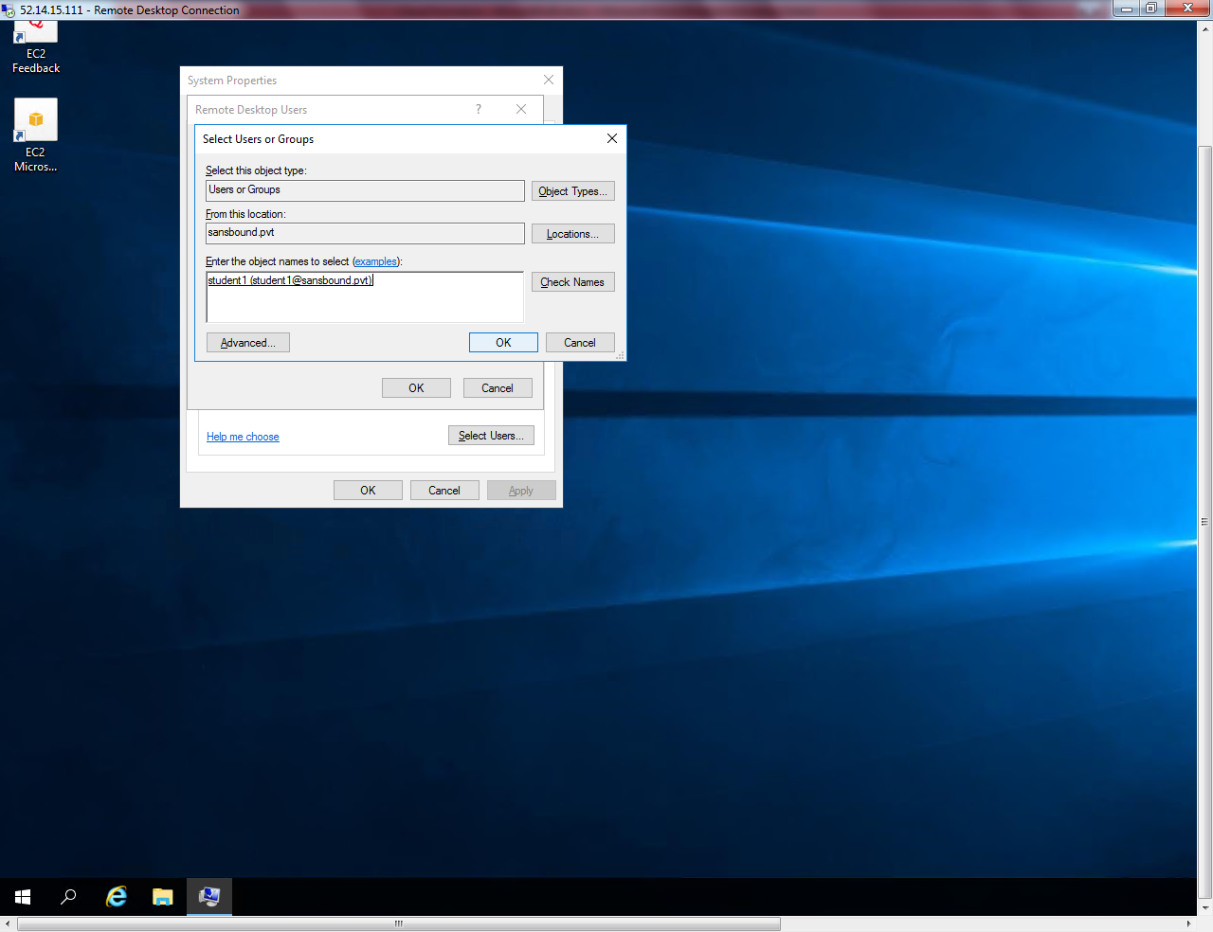

Click “Ok”.

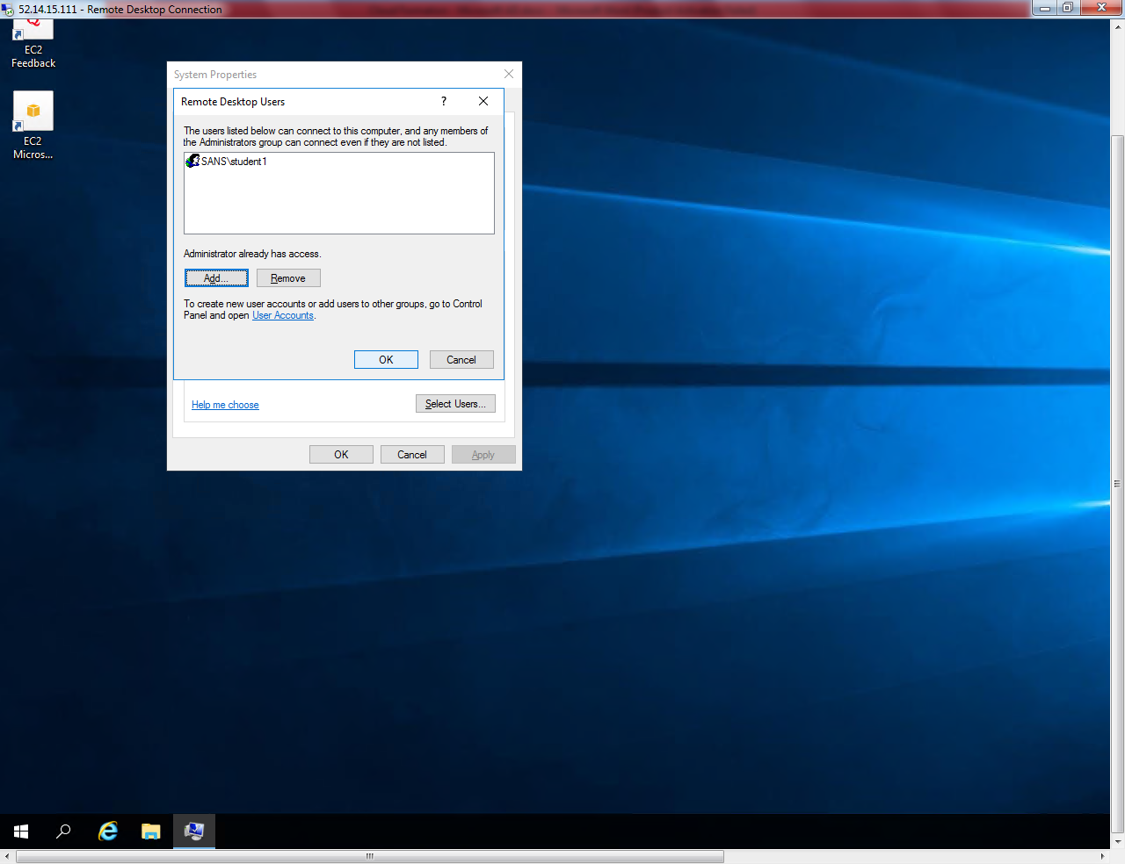

Click “OK”.

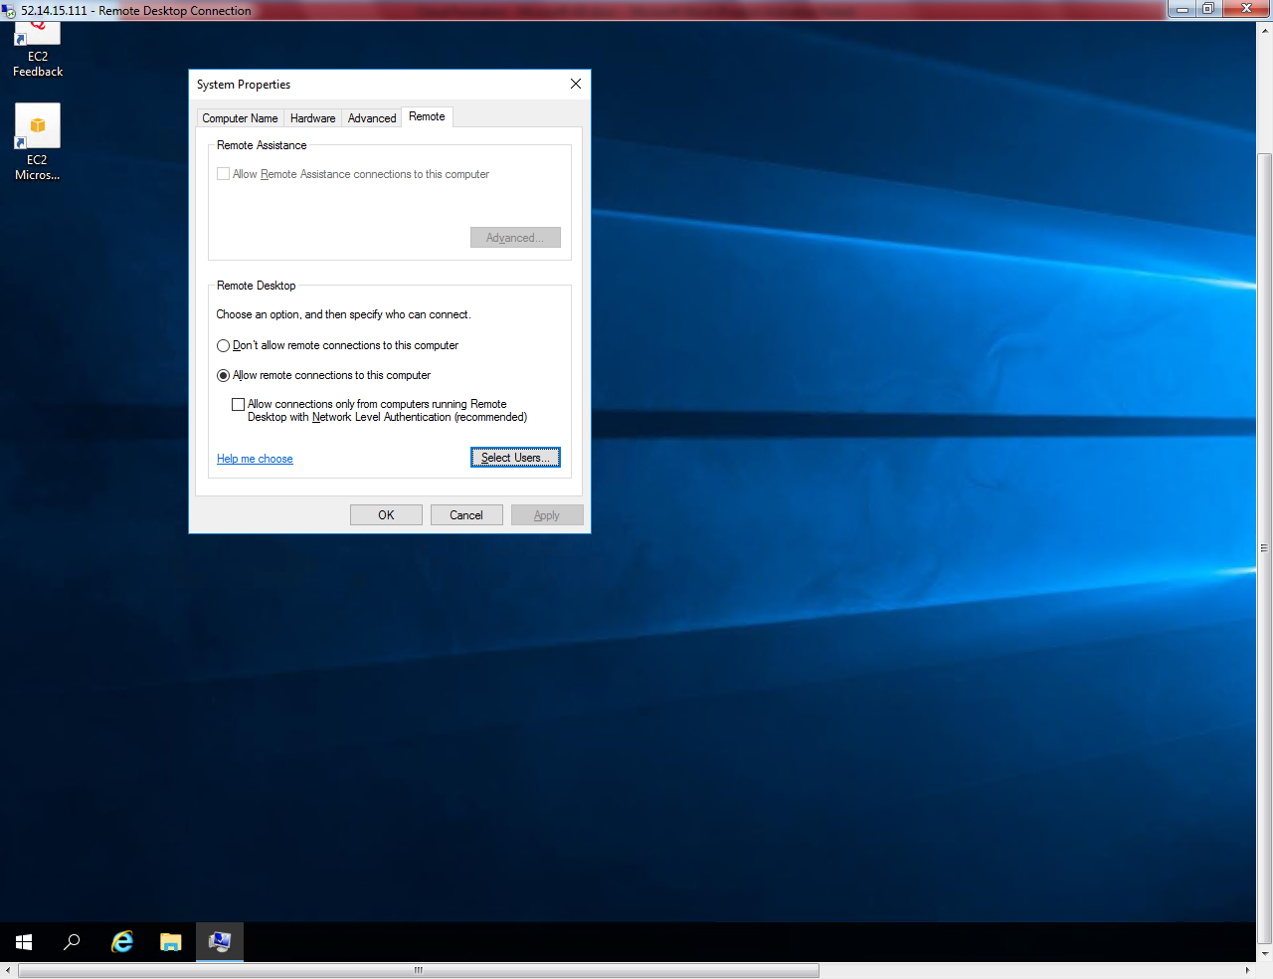

Sign out from the member server.

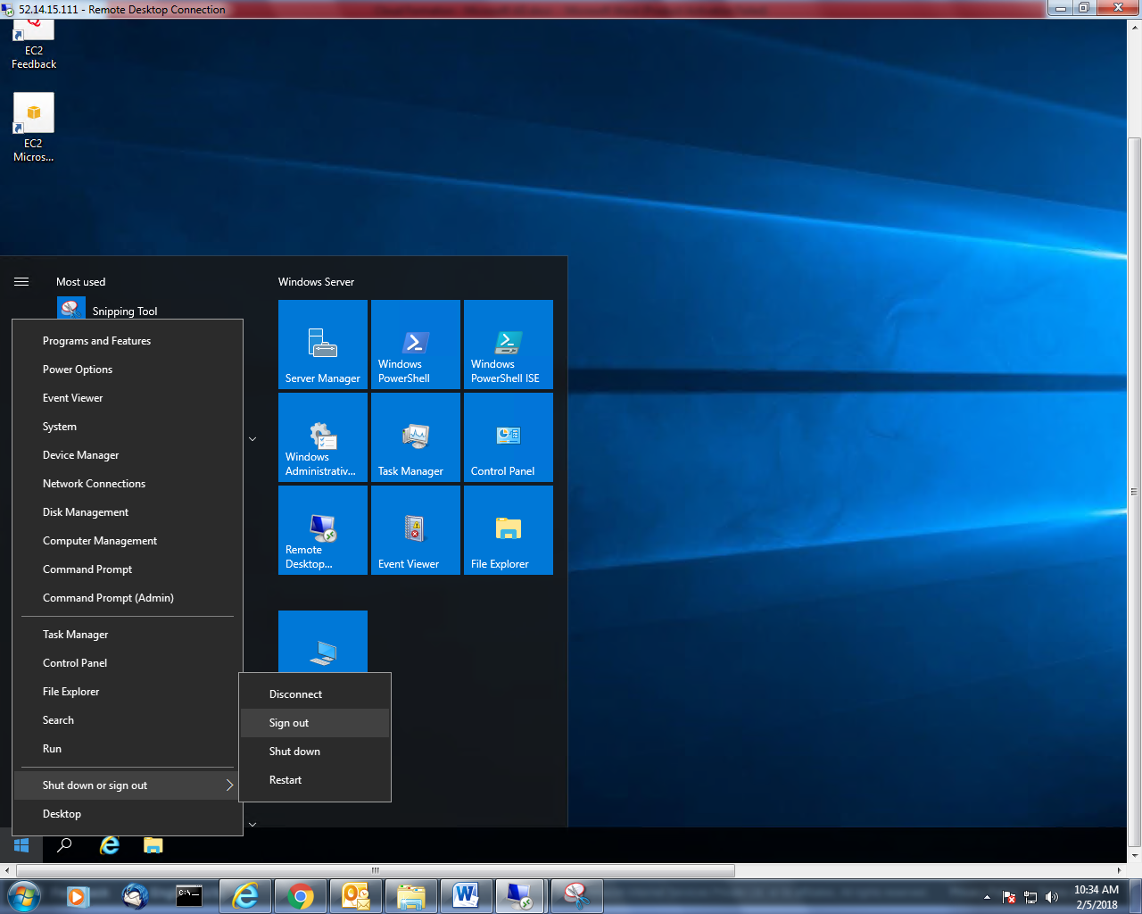

Login to member server with student1 login credentials.

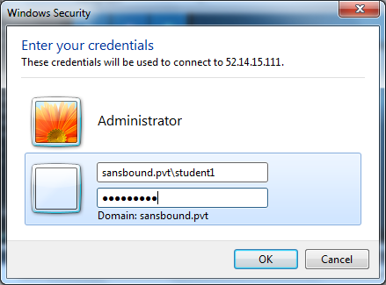

Now, you have successfully logged on to the server.

